

THE OKLAHOMA PIPELINE ENERGY STORAGE SYSTEM (OPESS) A-Spec

By Jonathan Grinnell

FALL 2022



EN.645.800

Mentor Robert Krzystan

|  |  |  |
| --- | --- | --- |
| Document Name | Date | Reason for Change |
| Grinnell_A-Spec | 11/18/22 | Initial Document |
| Grinnell_A-Spec_A | 11/19 | Document updated with Section 6, 3.6 and Appendix B |

Contents

Table of Figures 4

Table of Tables 4

1 A-Spec Report Description 5

2 OPESS ConOps 6

2.1 System Need 6

2.2 System Block Diagram 6

2.2.1 OPESS Block Diagram 6

2.2.2 ESS Block Diagram 7

2.2.3 CaCS Block Diagram 8

3 Requirement Analysis 10

3.1 Requirement Developmental History 10

3.2 System Requirements 10

3.4 Key Performance Parameters 11

3.3 Requirement Verification 12

3.5 Requirements Metric 13

3.6 Model Based Systems Engineering Tools 13

4 Earned Value Management 14

4.1 Schedule 14

4.2 Milestones 14

4.3 EVM 15

4.4 CPI and SPI Index 16

5 Risk 17

5.1 Risk 1: Weather 17

5.2 Risk 2: Earthquake 18

5.3 Risk 3: Residual Natural Gas 19

5.4 Risk 4: Cyber Security 20

6 Prototyping 21

7 References 22

8 Appendix A: Requirements 23

8.1 Originating Requirements 23

8.2 Design Constraints 29

8.3 Performance Requirements 33

8.4 Functional Requirements 43

9 Appendix B: Core Project 67

10 Appendix C: VCRM 68

# Table of Figures

Figure 1: OPESS Block Diagram End of A-Spec Version 7

Figure 2:ESS Block Diagram End of A-Spec Version 8

Figure 3: CaCS Block Diagram End of A-Spec Version 9

Figure 4: A-Spec Schedule 14

Figure 5: CPI/SPI 16

Figure 6: Risk 1 Weather 17

Figure 7: Risk 2 Earthquake 18

Figure 8: Risk 3 Residual Natural Gas 19

Figure 9: Risk 4 Cyber Security 20

# Table of Tables

Table 1: MOE Summary 5

Table 2 List of Solution Needs 6

Table 3: Requirement Type 10

Table 4: Key Performance Parameters 11

Table 5: KPP Description 11

Table 6: Verification Method 13

Table 7: Requirements Metric 13

Table 8: Milestones 14

Table 9: EVM 15

Table 10: Risk 1 Requirements 17

Table 11: Risk 2 Requirements 18

Table 12: Risk 3 Requirements 19

Table 13: Risk 4 Requirements 20

Table 14: VCRM 68

# 1 A-Spec Report Description

The **A-Spec report (A-Spec)** will be delivered as the seventh delivery of the **Oklahoma Pipeline Energy Storage System (OPESS)**. This report will be composed of a Concept of Operations as well as an analysis of the requirements. Schedule, EVM and CPI/SPI will also be discussed during this project. The risks first detailed in the OPESS proposal will be updated with any risk reduction efforts that were performed in the functional development phase of the OPESS Project.

The concept of operations will provide a description of the functional need that the OPESS aims to fill. It will focus on spelling out the current makeup of the Oklahoma power grid, its increasing reliance on renewable sources of energy and why a new energy solution will be needed to meet future demand. After that, the ConOps will dive further into the design of the OPESS system through the use of block diagrams in an attempt to flesh out the two subsystems that compose the OPESS.

The A-Spec, as discussed in section 3, will provide a detailed analysis of the OPESS requirements. The format of which will be very reminiscent of what was done under the RAR. However, multiple iterations of the OPESS development cycle have been executed during the FAR, TS, CDR and TP deliveries. As such the requirements have been further developed and evolved since the delivery of the RAR. This report is meant to examine the system as it exists now.

This document will also provide an update of the EVM as it stands as of this writing. Schedule updates, deliveries, the WBS and SPI/CPI will be discussed in this section.

Risks will be the last real section of the A-Spec. In this section, the risks outlines in the initial proposal will be updated and new risk reduction techniques developed during the requirement development stage will be taken into account.

Lastly, a list of all the requirements and a Verification Cross Reference Matrix (VCRM) will be attached as appendixes to this report.

All KPP’s listed in section 3 trace to MOE 2 through MOE 4. These MOEs can be found in the table below. These remain unchanged from the RAR.

Table : MOE Summary

| MOE Number | Summary |
| --- | --- |
| MOE 1 | The energy efficiency of the OPESS must be high enough to be of worth to the market. |
| MOE 2 | The ESS must be able to store energy on the time span of months to years. |
| MOE 3 | The OPESS much adhere to proper cyber security standards. |
| MOE 4 | The ESS should be able to stand up to the elements. |
| MOE 5 | The OPESS must not produce carbon emissions. |

MOE 1 was left was not referenced by the KPPs since that particular MOE is really more of a market and financial requirement. This MOE is still an important one to have listed and reference as this requirement will ultimately be what decides the viability of the OPESS system.

# 2 OPESS ConOps

## 2.1 System Need

In 2010 Oklahoma mandated that 15% of the state’s energy needs be provided by some form of renewable energy source. As early as 2012 the state surpassed that goal (Popovich & Plumer, 2020). In 2021, the amount of energy produced by renewable sources accounted for 45% of the state’s energy needs. That number continues to increase as new wind projects are stood up and roof top solar becomes more popular. Unfortunately, wind and solar are not a source of consistent power. When the sun goes down homeowners are forced to either pull power from a grid that still produces energy primarily from dirty sources or from an expensive battery pack. High pressure systems can also move in, causing time periods of low wind energy production or worse yet, strong winds can come in during storm season and produce an excess of wind energy, forcing wind turbines offline.

The solution is to install large amounts of grid level energy storage. This will help even out the peaks and valleys of energy production, allowing energy produces on high energy days to be used on low energy days. Batteries are expensive and will compete with electric cars as their demands rises and pumped hydro can’t really be used in Oklahoma as the state neither gets the required amount of rain or has enough in the way of mountains to make it practical.

What the state does have in abundance are natural gas wells. It is through the use of this resource common to the state that a form of green energy storage can be developed. A list of solution needs can be found is table 2.

Table List of Solution Needs

|  |  |  |
| --- | --- | --- |
| Number | Name | Description |
| 1 | Extra Storage | The OPESS needs to be able to store extra energy from renewable sources during times of over production. |
| 2 | Low-Cost Storage | The OPESS needs to be able to store energy produced on the grid during low rates for use during times of high rates |
| 3 | Long Term Storage | The OPESS needs to be able to store energy for a significant amount of time with minimal loss. This will be measured on the timeframe of months to years. |
| 4 | Grid Scale Storage | The OPESS needs to be able to provide an energy storage solution that can be maintained on a grid level. |

## 2.2 System Block Diagram

The system block diagrams were produced during the RAR. They have been modified a bit as the design of the OPESS has changed though they have remained relatively intact for the most part. The block diagrams can be found in the sections below.

### 2.2.1 OPESS Block Diagram

The OPESS is composed of two major subsystems. The first is the Energy Storage Subsystem (ESS). The ESS is the actual storage system of the OPESS system. Functionally, it pulls power off the grid, compressed air for storage in spend natural gas wells, and then used that gas to spin a turbine for use on the grid. Since this device is outside, it is exposed to the elements and will thus need to be protected.

The second major subsystem is the Command-and-Control Subsystem (CaCS). As its name suggests, it performs the command-and-control functionality of the OPESS system. The CaCS allows communication between the OPESS and other utility companies and plants that might be powering the grid at the time. The CaCS communicated with the ESS over a secured internet connection.

Figure : OPESS Block Diagram End of A-Spec Version

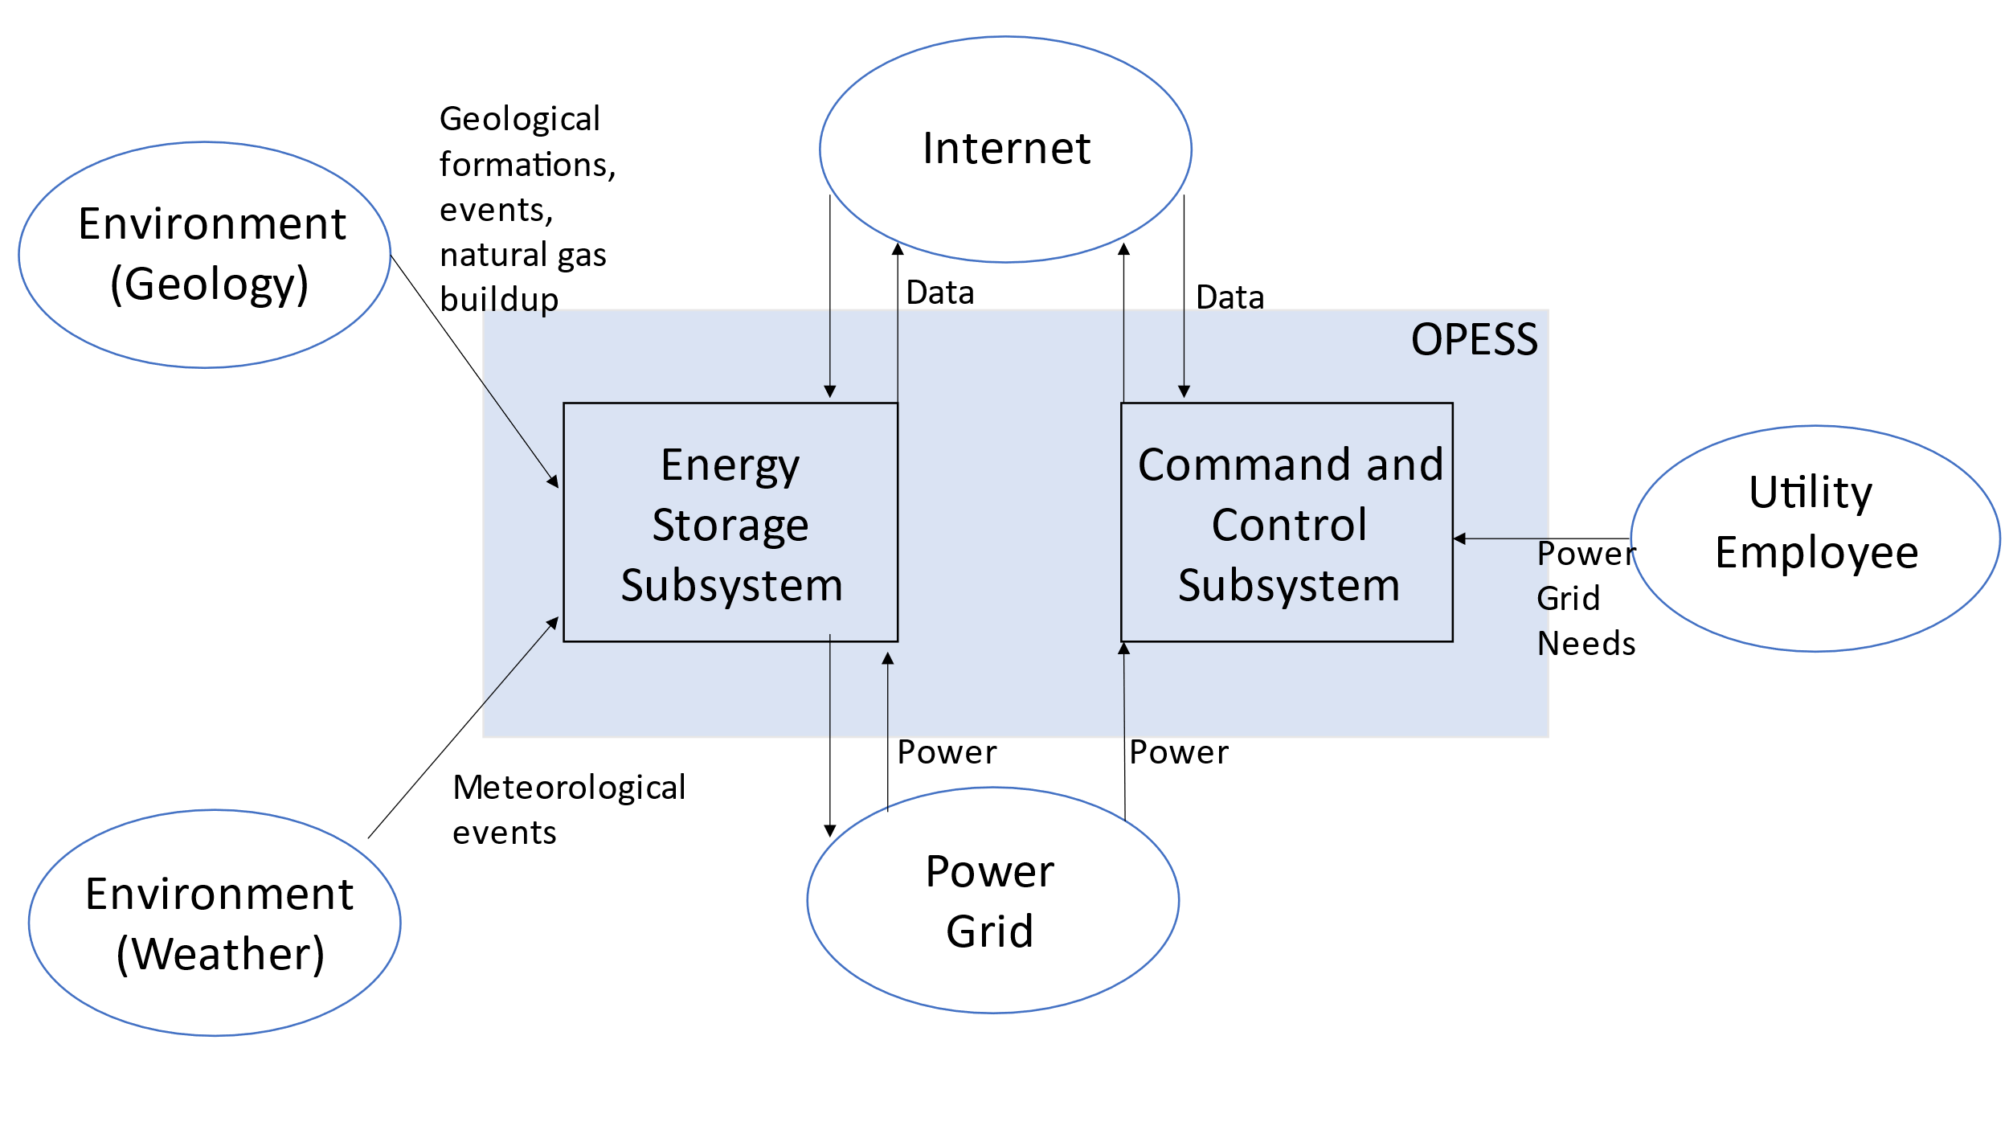

### 2.2.2 ESS Block Diagram

The ESS is the heart of the OPESS. It is composed of 5 functions, receive power, store power, generate power, a control node and weather protection. The primary function of the ESS is to act as a battery, hence the first three functions, however, unlike a batter, this is a complicated piece of equipment with lots of moving parts. A localized control note will have to be included in order to tell the individual components of the ESS how to behave. Additionally, this node will communicate with the CaCS and report and health and status issues the ESS might be experiencing.

Additionally, per risk 1, the ESS will be exposed to the elements on a regular bases and Oklahoma is famous for its bad weather. The final function, weather protection, is a risk reduction function meant to protect the ESS.

Figure :ESS Block Diagram End of A-Spec Version

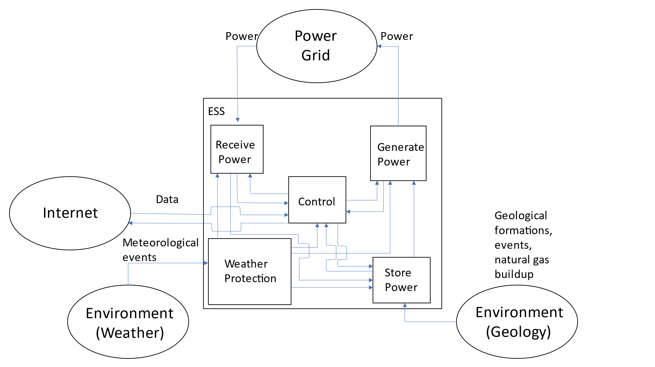

### 2.2.3 CaCS Block Diagram

The CaCS is the brains of the OPESS system. It exists primarily as an office space that allows utility workers, economists and engineers to communicate with other facilities both locally and across state lines in an effort to figure out what the future and current electrical needs will be. The CaCS will be able to allow employees access to modeling software in an effort of predict the future needs of the OPESS system on the grid. The CaCS will also allow employees to log into the ESS from their desk, monitor health and status and even control the ESS without having to go into the field. This will be helpful as issues can be diagnosed and handled without sending out technicians into the field.

Figure : CaCS Block Diagram End of A-Spec Version

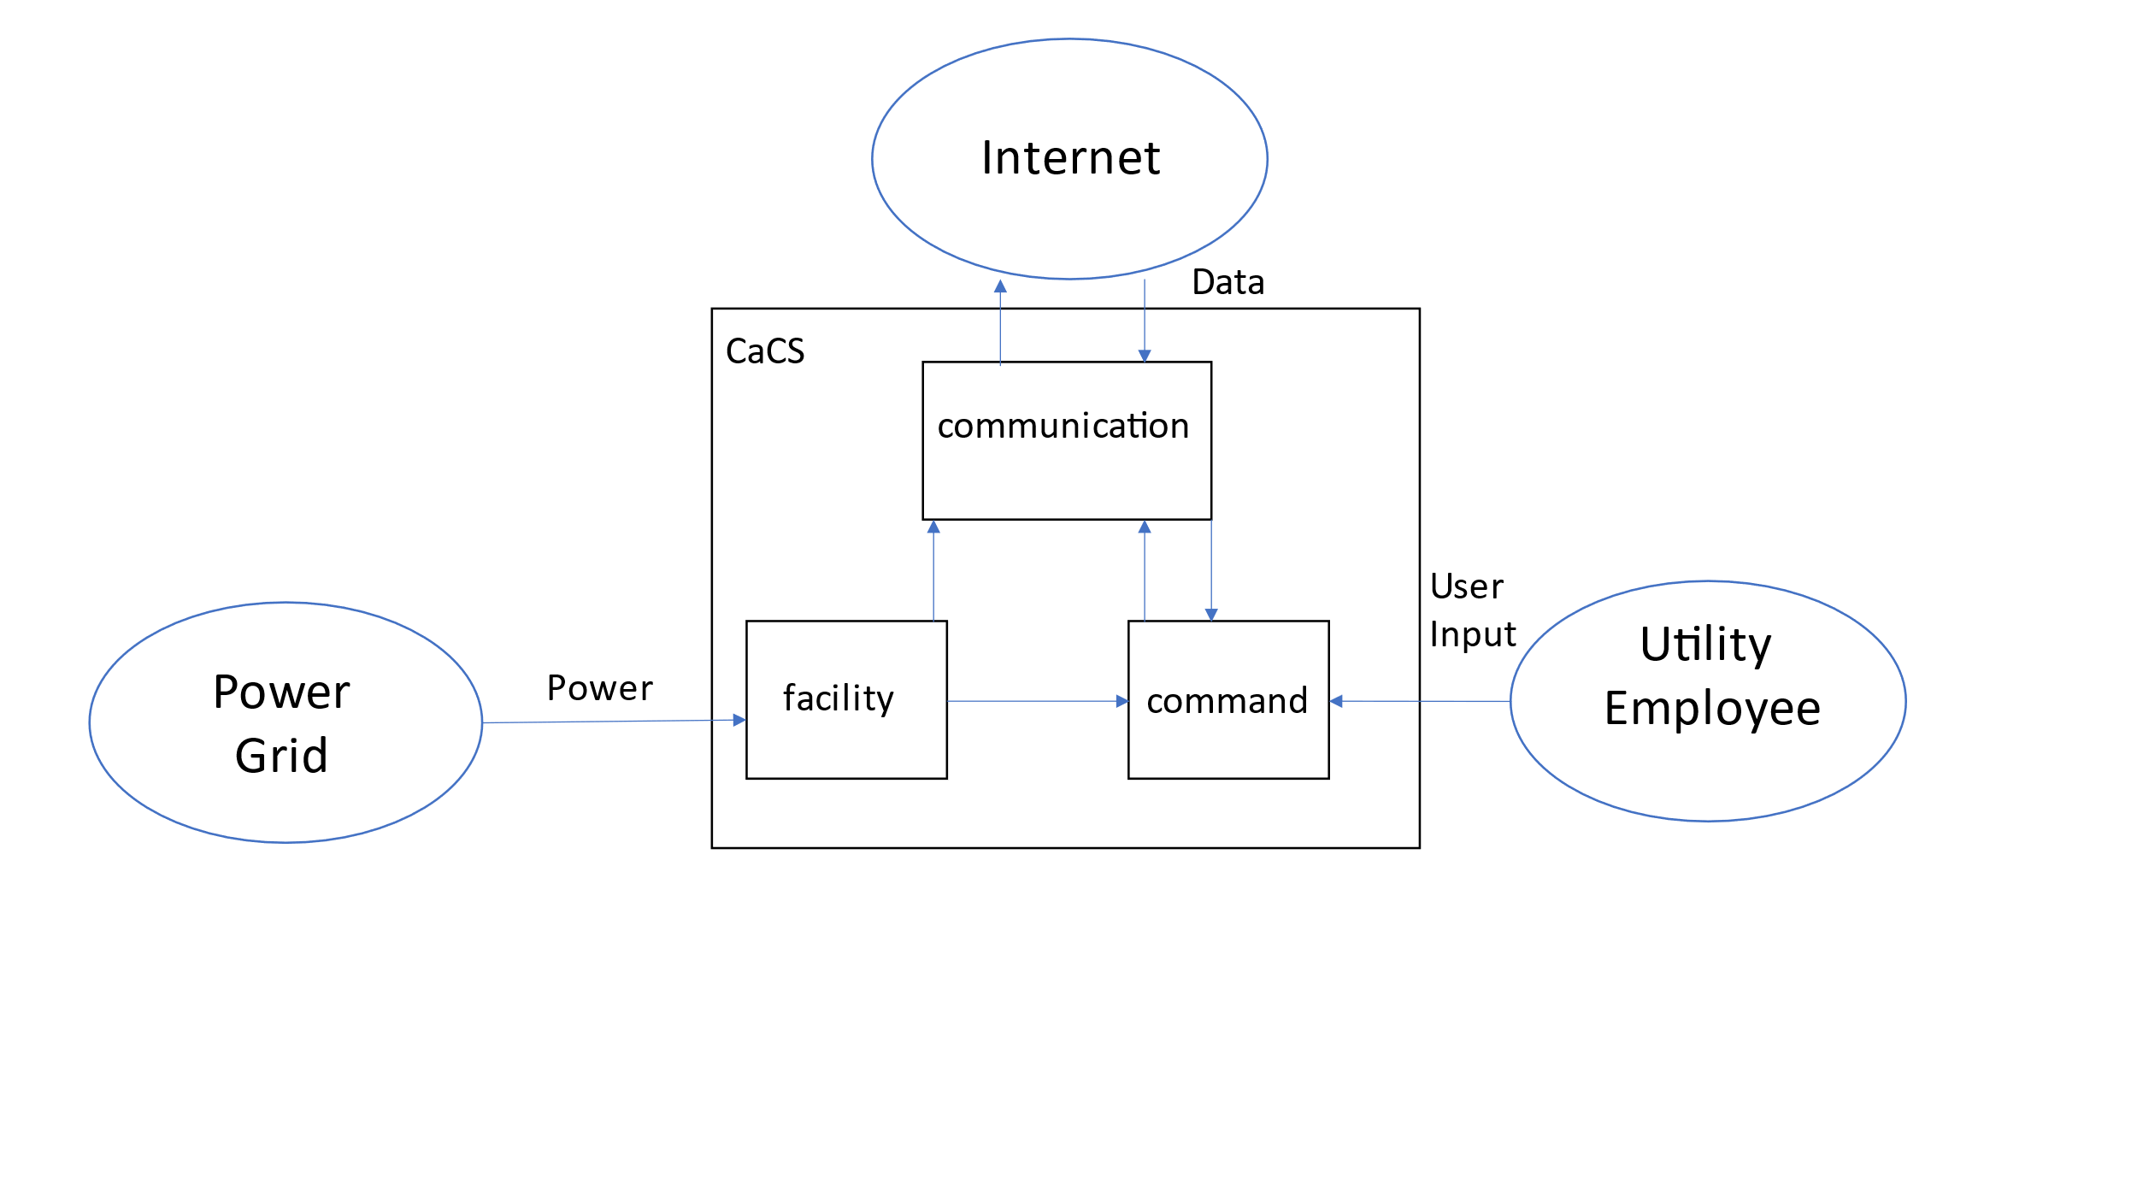

# 3 Requirement Analysis

## 3.1 Requirement Developmental History

The requirements for the OPESS system were originally created during the RAR based on multiple interviews. Three classes of experts, being a cyber security professor, economist for a local utility company and a petroleum engineer were contacted to get a baseline of how these systems would work and what system needs would be required. Unfortunately, a none of the petroleum engineers contacted were willing to give interviews.

Fortunately, the research being conducted during that time period happened to be quite fruitful as the US Department of Energy had actually done a bit of research into the topic of storing compressed air inside natural gas wells. As such, while an interview from a petroleum engineer would be helpful, ultimately, requirements could be derived based on already published information.

## 3.2 System Requirements

The requirements written for the OPESS system can be broken up into four different types:

Originating Requirements: The requirements stem from interviews from experts on various topics. They sometimes fill a performance or functional role in the OPESS system and can mostly be found labeled as both a originating and a performance/functional requirement.

Design Constraint: Design Constraints are choices that were made on the part of a requirement to achieve a goal. For example, “shall store energy” may be a functional phrase but “shall use a natural gas well” is a design choice on the part of the OPESS system.

Performance Requirements: Performance Requirements are any requirement that specifies some measure of performance of the OPESS system. These can be found as percentages, amounts or minimal standards as in the case of some software requirements.

Functional Requirements: Functional Requirements are requirements that provide or describe a function of the system. The phrase “shall store energy” describes a function of the OPESS system.

Table : Requirement Type

|  |  |
| --- | --- |
| Requirement Type | Number |
| Originating Requirements | 21 |
| Design Constraints | 21 |
| Performance Constraints | 40 |
| Functional Constraints | 69 |
| Total | 151 |

Additionally, since some of the Originating Requirements can double as both Functional or Performance most of them have actually been counted twice in the OPESS system with the exception of one. As such, that 151 number presented in Table 6 should actually read 131.

## 3.4 Key Performance Parameters

Key performance parameters (KPP’s) are requirements that were developed specifically to dictate key functions or standards important to the OPESS. These requirements form the backbone of the system.

Table : Key Performance Parameters

|  |  |
| --- | --- |
| Key Performance Parameters | Number |
| True | 12 |
| False | 119 |

Table : KPP Description

| KPP # | Req. # | Req. Name | Req. Description | Quantitative Vs. Qualitative | Verification Method |
| --- | --- | --- | --- | --- | --- |
| 1 | 1.1.1.5 | ESS Internet Interface | The ESS control node shall maintain a secure connection with the CaCS. | Qualitative | VerificationRequirement Test |
| 2 | 1.1.2.1.3 | ESS Generator Storage Interface | The ESS generator shall use compressed air coming from the natural gas well to spin a turbine and generate power. | Qualitative | VerificationRequirement Demonstration |
| 3 | 1.1.2.4.1 | ESS Carbon Capture Percent | The ESS carbon capture system shall remove no less than 50 percent of the hydrocarbons from the compressed air. | Quantitative | VerificationRequirement Test |
| 4 | 1.1.3.2.2 | ESS Storage Time | The ESS storage shall be able to keep compressed air for a period of up to 1 year. | Quantitative | VerificationRequirement Demonstration |
| 5 | 1.1.3.3.2 | ESS Storage Gas Safety Sensor | The ESS pressurized connection shall have an emergency release when the gas mixture reaches 4% according to the sensors. | Quantitative | VerificationRequirement Test |
| 6 | 1.1.3.3.4 | ESS Storage Leak | The ESS shall not allow the pressurized connection to leaked at a rate of more than 5% a year. | Quantitative | VerificationRequirement Test |
| 7 | 1.1.3.3.5 | ESS Storage Pressure | The ESS pressurized connection shall be able to handle up to 300 PSI. | Quantitative | VerificationRequirement Test |
| 8 | 1.1.4.1.1 | ESS Air Compressor | The ESS pump shall compress air and send it to the natural gas interface at pressure. | Qualitative | VerificationRequirement Demonstration |
| 9 | 1.1.5 | ESS Weather | The ESS shall be protected from the weather. | Qualitative | VerificationRequirement Test |
| 10 | 1.2.1.3 | CaCS Syber Security | The CaCS shall have a secure connection to the internet. | Qualitative | VerificationRequirement Test |
| 11 | 1.2.3 | CaCS Utility Interface | The CaCS shall receive data and commands from local utility employees. | Quantitative | VerificationRequirement Demonstration |
| 12 | 1.2.3.6 | CaCS Models | The CaCS shall provide software capable of creating and using utility models. | Qualitative | VerificationRequirement Demonstration |

## 3.3 Requirement Verification

The requirements are verified through four verification methods.

Inspection: An inspection requirement is any requirement that can be verified via looking or some form of observation. Potential examples could be something like confirming a piece of software is coded per requirement or looking at a documented spec from a supplier.

Analysis: An analysis requirement is any requirement that requires multiple runs so that data can be built up. This data can then be analyzed to confirm that the behavior meets the requirement.

Demonstration: A demonstration requirement is any requirement that requires a demonstration of the functionality. An example might be like confirming that a pipe can hold up to 30 psi. Once the pipe is filled to that level, the requirement passes.

Test: A test requirement is any requirement that requires some form of formal test procedure. These can be related to demonstration requirements but typically require confirming consistent behavior of the system under multiple situations.

Table : Verification Method

| Verification Method | Number |
| --- | --- |
| Inspection | 43 |
| Analysis | 16 |
| Demonstration | 44 |
| Test | 28 |
| Total | 131 |

## 3.5 Requirements Metric

The below table presents a list of all the metrics regarding the requirements derived at this point in time. This table will summarize the number of total requirements, KPP’s, qualitative vs quantitative and how each requirement will be verified.

Table : Requirements Metric

|  |  |  |  |  |  |  |  |  |
| --- | --- | --- | --- | --- | --- | --- | --- | --- |
| Report | Requirements | KPP’s | Qualitative | Quantitative | Inspection | Analysis | Demonstration | Test |
| RAR | 104 | 12 | 50 | 54 | 29 | 14 | 37 | 24 |
| FAR | 129 | 12 | 75 | 54 | 37 | 16 | 48 | 28 |
| TS | 131 | 12 | 79 | 52 | 43 | 16 | 44 | 28 |
| CDR | 131 | 12 | 79 | 52 | 43 | 16 | 44 | 28 |
| TP | 131 | 12 | 79 | 52 | 43 | 16 | 44 | 28 |
| A-Spec | 131 | 12 | 79 | 52 | 43 | 16 | 44 | 28 |
| Final |  |  |  |  |  |  |  |  |

## 3.6 Model Based Systems Engineering Tools

CORE was used during the development of the OPESS. CORE is a Model Based Systems Engineering (MBSE) tool that aids in the development of requirements, functions, and components, allowing these to point to each other to allow for full traceability from requirements to functions to components and back to requirements. CORE allows for the automatic creation of N2 Diagrams, functional diagrams and other methods for tracking linkages and behaviors of the system. This tool was used repeatedly during the development of the OPESS with its output present in a majority of the reports presented. The CORE executable is available attached as an appendix to the A-Spec.

# 4 Earned Value Management

## 4.1 Schedule

The schedule being worked as of this moment assumes a final due date of around the 14th of December. This was based on the schools calendar for when the semester would be over and not based on any agreed date for presentation. However, since that date has since been agreed to, this paper is being turned in ahead of time to account for the new compressed deadline. The schedule however, has not changed since EVM rules specifically forbid the changing of a baseline that is less then current month plus one out.

Figure : A-Spec Schedule

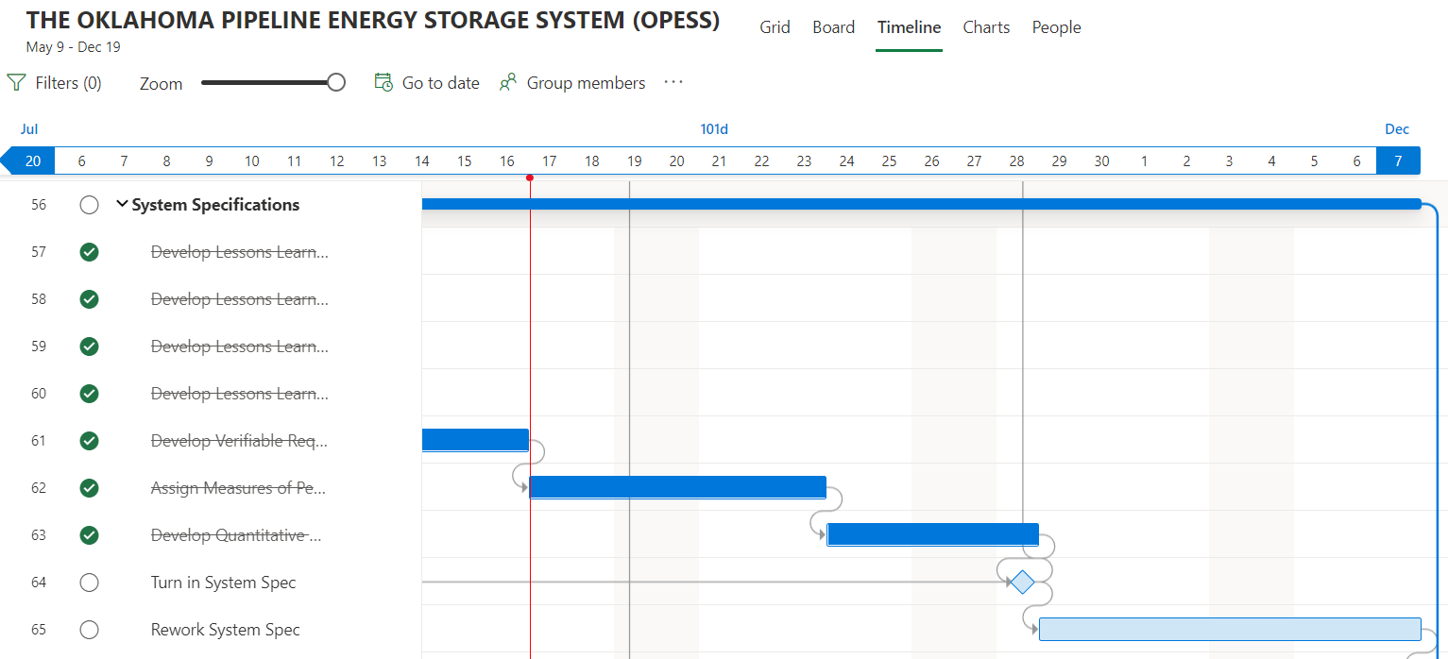

## 4.2 Milestones

Milestones Items in red were turned in late per the original due date. Green have been turned in ahead of schedule. All other deliveries are expected to be ahead of schedule.

Table : Milestones

| **Milestone** | **Date** |
| --- | --- |
| Project Proposal | 7/8/2022 |
| Requirements Report | 8/12/2022 |
| Functional Analysis | 9/2/2022 |
| Trade Study | 9/7/2022 |
| Concept of Operations | 10/8/2022 |
| Test Plan | 11/5/2022 |
| System Specifications | 11/17/2022 |
| Risk Management Report | 12/1/2022 |
| Final Report | 12/13/2022 |
| Oral Presentation | 12/14/2022 |

## 4.3 EVM

Table : EVM

| WBS number | Name | % Complete | Budget | BCWP | ACWP | SPI | CPI |
| --- | --- | --- | --- | --- | --- | --- | --- |
| **9** | **System Specifications** | **88.89%** |  |  |  |  |  |
| 9.1 | Develop Lessons Learned from Requirements Analysis | 100.00% | 1 | 1.00 | 1 | 1 | 1.00 |
| 9.2 | Develop Lessons Learned from Functional Analysis | 100.00% | 1 | 1.00 | 1 | 1 | 1.00 |
| 9.3 | Develop Lessons Learned from Physical Analysis | 100.00% | 1 | 1.00 | 1 | 1 | 1.00 |
| 9.4 | Develop Lesions Learned from Trade Study | 100.00% | 1 | 1.00 | 0.1 | 1 | 10.00 |
| 9.5 | Develop Verifiable Requirements (VCRM) | 100.00% | 10 | 10.00 | 1 | 1 | 10.00 |
| 9.6 | Assign Measures of Performance to all Requirements | 100.00% | 5 | 5.00 | 0.1 | 1 | 50.00 |
| 9.7 | Develop Quantitative Requirements Metric | 100.00% | 3 | 3.00 | 0.1 | 1 | 30.00 |
| 9.8 | Turn in System Spec | 100.00% | 0.5 | 0.50 | 0.1 | 1 | 5.00 |
| 9.9 | Rework System Spec | 0.00% | 10 | 0.00 |  | 0 |  |

## 4.4 CPI and SPI Index

Figure : CPI/SPI

# 5 Risk

No New risks were discovered during the A-Spec.

## 5.1 Risk 1: Weather

Figure : Risk 1 Weather

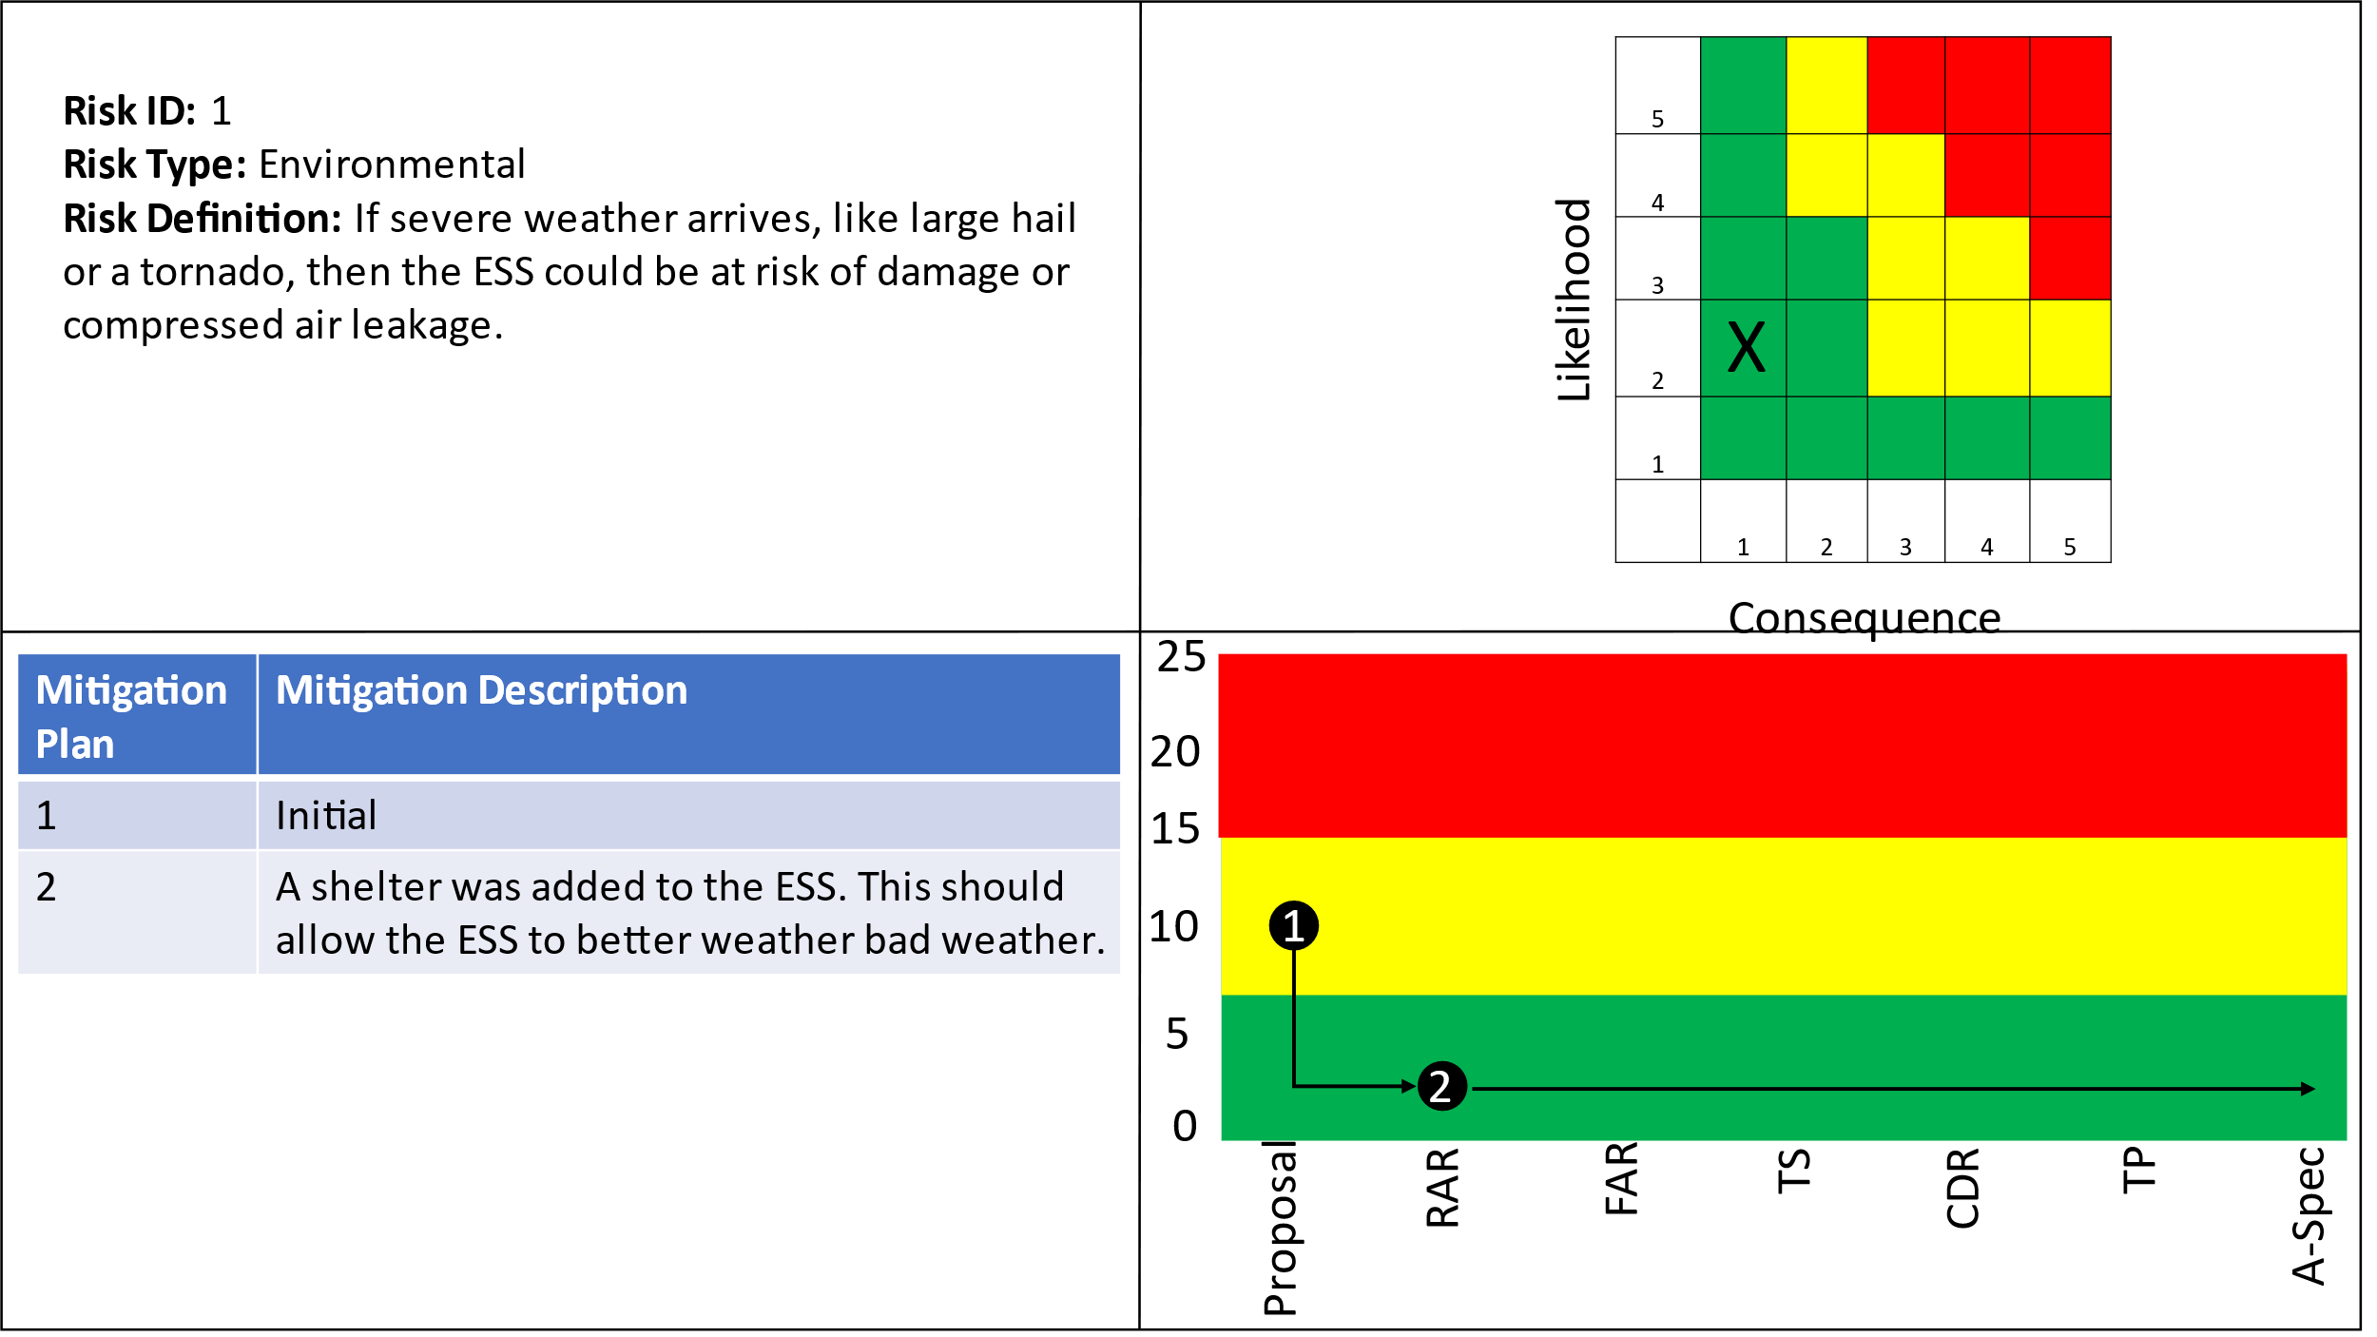

Table : Risk 1 Requirements

|  |  |  |  |
| --- | --- | --- | --- |
| Requirement Number | Requirement Name | Requirement Number | Requirement Name |
| 1.1.5 | ESS Weather | 1.1.5.1 | ESS Cooling |
| 1.1.5.2 | ESS Hail | 1.1.5.3 | ESS Heating |
| 1.1.5.4 | ESS Tornado | 1.1.5.5 | ESS Wind |
| 1.1.5.6 | Weather Protect | 1.1.5.7 | Climate Control |

## 5.2 Risk 2: Earthquake

Figure : Risk 2 Earthquake

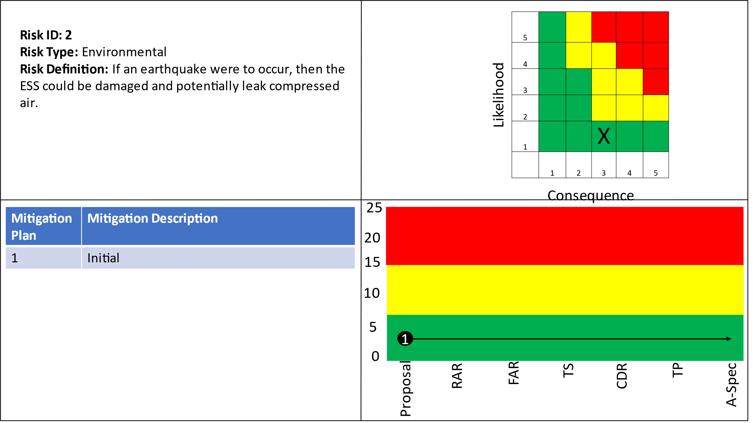

Table : Risk 2 Requirements

|  |  |  |  |
| --- | --- | --- | --- |
| Requirement Number | Requirement Name | Requirement Number | Requirement Name |
| 1.1.3.1.2 | ESS Storage pressure monitoring |  |  |

## 5.3 Risk 3: Residual Natural Gas

Figure : Risk 3 Residual Natural Gas

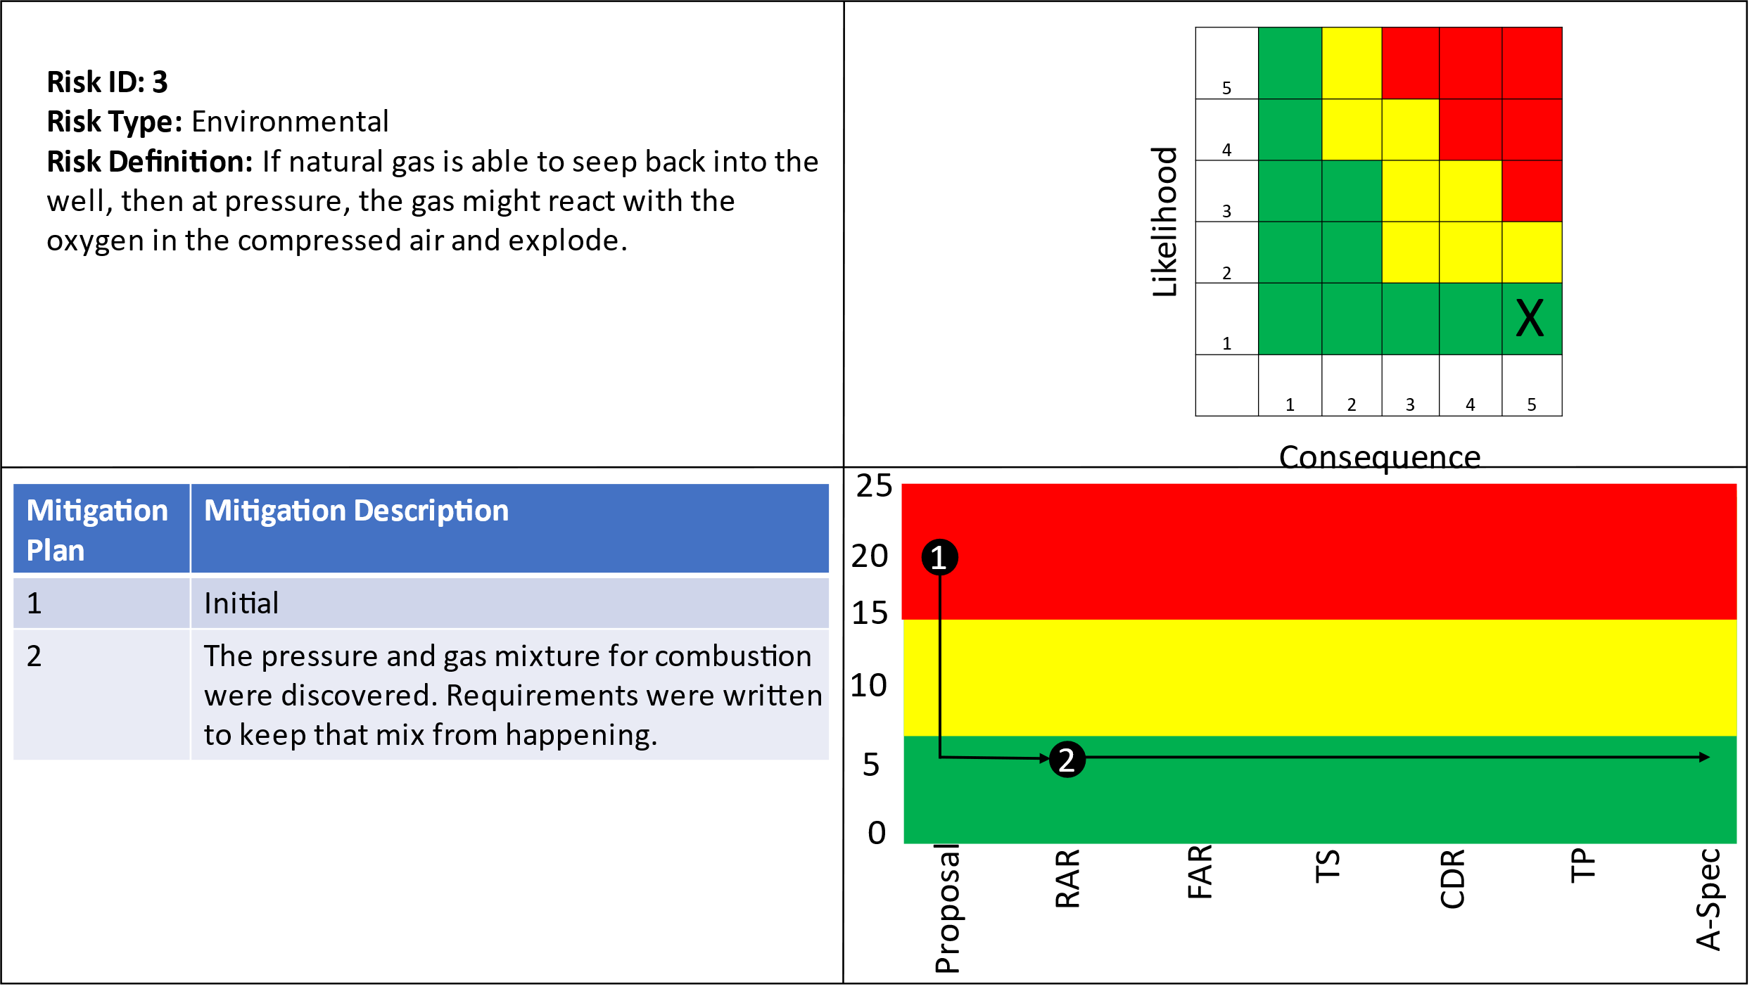

Table : Risk 3 Requirements

|  |  |  |  |
| --- | --- | --- | --- |
| Requirement Number | Requirement Name | Requirement Number | Requirement Name |
| 1.1.3 | ESS Power Storage | 1.1.3.1 | ESS Compressed air monitoring |
| 1.1.3.1.1 | ESS Gas Monitoring | 1.1.3.1.2 | ESS Storage pressure monitoring |
| 1.1.3.1.3 | ESS Storage Sensors | 1.1.3.1.4 | ESS SW Max Gas mix |
| 1.1.3.1.5 | ESS SW Max PSI | 1.1.3.1.6 | Chemical Monitoring |
| 1.1.3.1.7 | Pressure Monitoring |  |  |

## 5.4 Risk 4: Cyber Security

Figure : Risk 4 Cyber Security

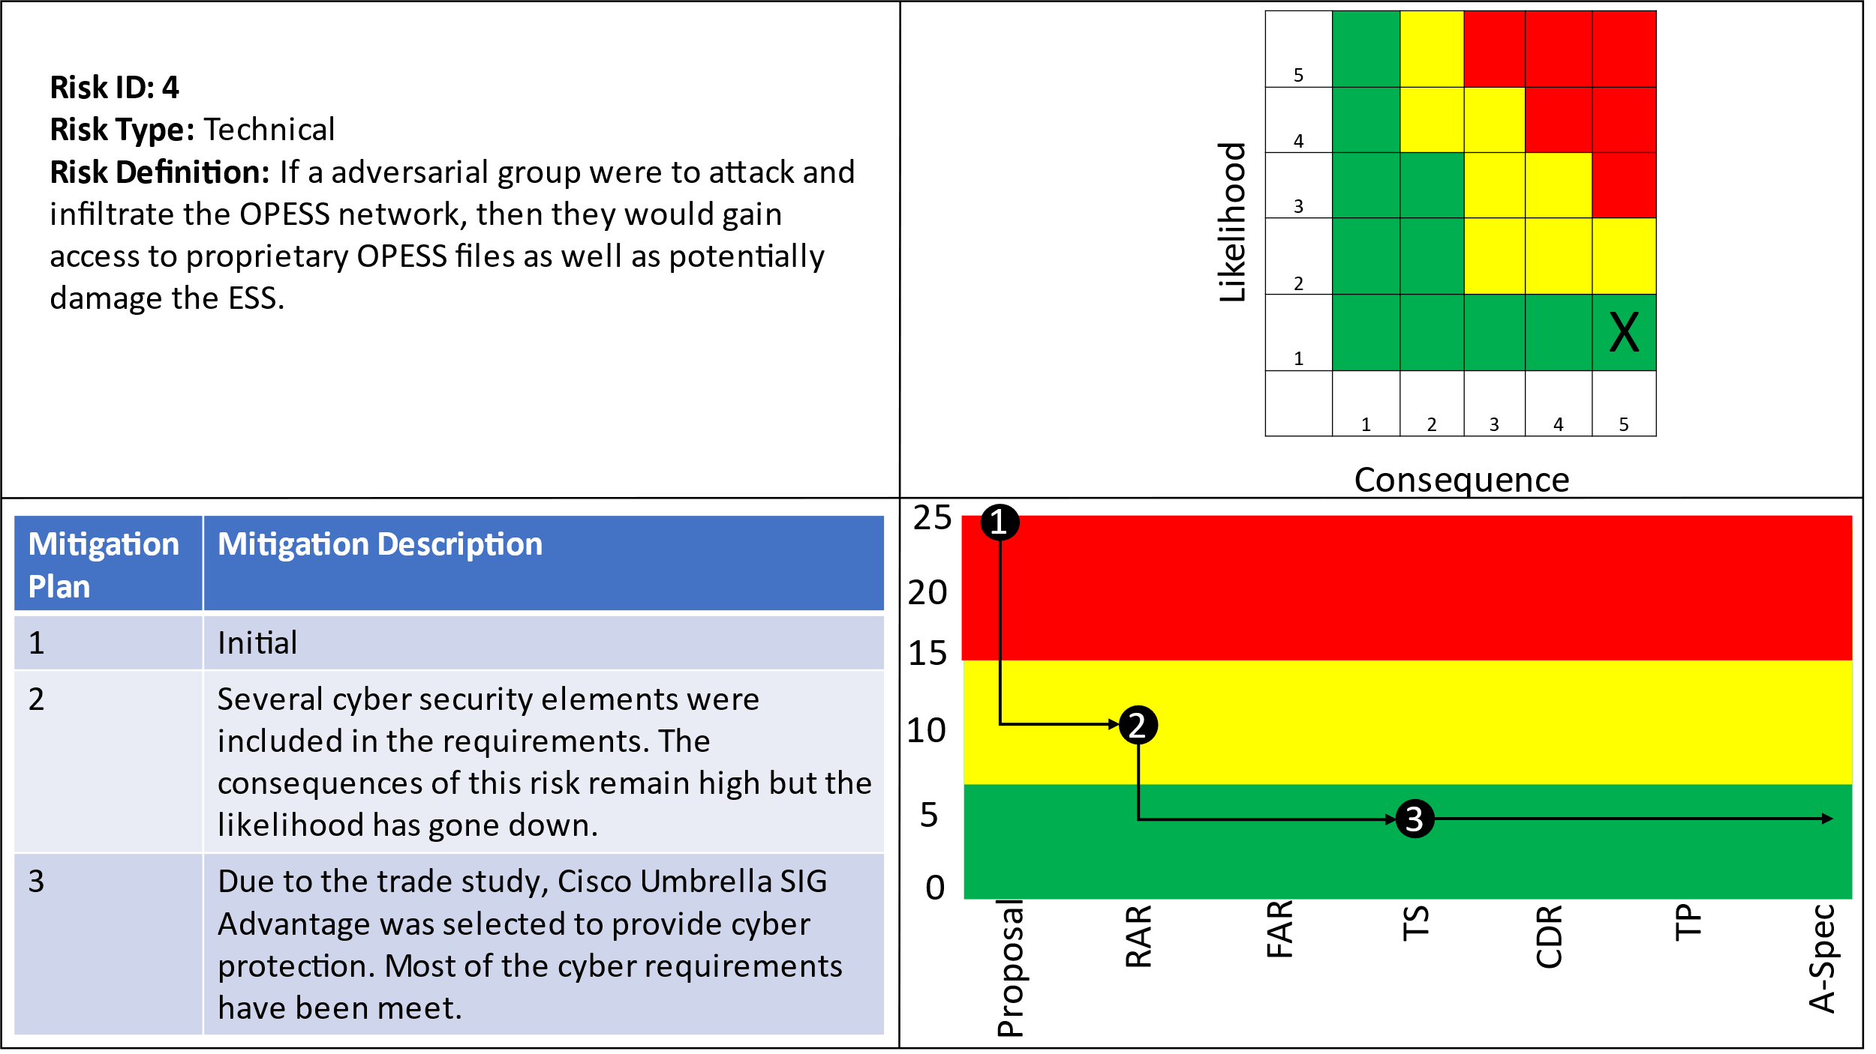

Table : Risk 4 Requirements

|  |  |  |  |
| --- | --- | --- | --- |
| Requirement Number | Requirement Name | Requirement Number | Requirement Name |
| 1.1.1.5 | ESS Internet Interface | 1.1.1.5.1 | ESS Cyber Scans |
| 1.1.1.5.2 | ESS Encryption | 1.1.1.5.3 | ESS Fiber Optics |
| 1.1.1.5.4 | ESS URL Filtering | 1.1.1.5.6 | ESS TCP/IP |
| 1.1.1.5.8 | ESS Cyber Security Suite | 1.1.1.5.9 | ESS Secure Connection |
| 1.1.1.5.10 | ESS IPS | 1.1.1.5.11 | ESS TLS |
| 1.1.1.5.12 | ESS DDoS Protection | 1.2.1.1.2 | CaCS Log In |
| 1.2.1.1.3 | CaCS Ring Network | 1.2.1.1.4 | CaCS Security Scan |
| 1.2.1.1.5 | CaCS VM | 1.2.1.2 | CaCS Servers |
| 1.2.1.3 | CaCS Syber Security | 1.2.1.3.1 | CaCS Anti-Virus |
| 1.2.1.3.2 | CaCS Cyber Filtering | 1.2.1.3.3 | CaCS Firewall |
| 1.2.1.3.4 | CaCS Intrusion Detection | 1.2.1.3.5 | CaCS TCP/IP |
| 1.2.1.3.6 | CaCS IPS | 1.2.1.3.7 | CaCS TLS |
| 1.2.1.3.8 | CACS DDoS Protection | 1.2.3.1 | CaCS Control |
| 1.2.3.1.1 | CaCS ESS Health and Status | 1.2.3.1.2 | CaCS ESS Interface |
| 1.2.3.1.3 | CaCS Two Factor Authentication |  |  |

# 6 Prototyping

The A-Spec is here to provide a road map on what the system should do but the execution of these requirements are left up to the individual developer engineers. Since the ESS stores energy in natural gas wells and these are natural formations, it is expected that lower-level solutions and requirement decompositions may be different for every instance of an ESS built.

It is expected that a vast majority of equipment needed for the construction of the OPESS will be Commercial Off The Shelf (COTS) part. It will be important that system engineers’ team up with specialists and Subject Matter Experts (SME’s) to perform trade studies into possible technical solutions to the requirements written in the A-Spec. These trade studies will help to provide an understanding of the components available and provide insight into the creation of lower-level requirements, models as well as physical and software spec documentation.

COTS products purchased on the part of the OPESS will need to be purchased based on the requirements written in the A-Spec. However, the lower-level development that would be required as a part of prototyping an OPESS solution has not been done and would need to be done by a team of specialists and SME’s. It is hoped that the models provided in the FAR and CDR, as well as the requirements in the A-Spec will provide an effective road map to future developers.

# 7 References

*Electricity explained: How electricity is delivered to consumers.* (2022, August 11). Retrieved from US Energy Information Administration: https://www.eia.gov/energyexplained/electricity/delivery-to-consumers.php

Grubelich, M. C., Bauer, S. J., & Cooper, P. W. (2011, September). *Potential Hazards of Compressed Air Energy Storage in Depleted Natural Gas Reservoirs.* Retrieved from Sandia Report: https://www.osti.gov/servlets/purl/1029814/

Popovich, N., & Plumer, B. (2020, 10 28). *How Does Your State Make Electricity?* Retrieved from The New York Times: https://www.nytimes.com/interactive/2020/10/28/climate/how-electricity-generation-changed-in-your-state-election.html

*The Basics of Underground Natural Gas Storage* . (2015, 11 16). Retrieved from US Energy Information Administration: https://www.eia.gov/naturalgas/storage/basics/

U.S. Energy Information Administration. (2022, May 19). *Oklahoma State Profile and Energy Estimates*. Retrieved from U.S. Energy Information Administration: https://www.eia.gov/state/analysis.php?sid=OK

# 8 Appendix A: Requirements

## 8.1 Originating Requirements

1 OPESS Requirements

Requirement Statement:

The Oklahoma Pipeline Energy Storage System (OPESS) shall operate as an energy storage system on the electrical grid.

Requirement Rationale:

Design decision

Refined By Subordinate Requirements:

1.1 ESS Requirement

1.2 CaCS Requirements

Basis Of:

Function: 1 Oklahoma Pipeline Energy Storage System

1.1.1.5.2 ESS Encryption

Requirement Statement:

The ESS connection to the CaCS shall be encrypted with an AES-256 connection or stronger

Requirement Rationale:

Derived from Interviews

Refines Higher-Level Requirement:

1.1.1.5 ESS Internet Interface

Basis Of:

Function: 1.1.2.1.2 ESS Cyber Security

Function: 1.1.6.1.2 Device Cyber Security

1.1.1.5.3 ESS Fiber Optics

Requirement Statement:

The ESS shall use either a IEEE802.3 Ethernet or Fiber Optic connection.

Requirement Rationale:

Derived from Interviews

Refines Higher-Level Requirement:

1.1.1.5 ESS Internet Interface

Basis Of:

Function: 1.1.2.1.3 ESS Network Interface

Function: 1.1.6.1.2 Device Cyber Security

1.1.1.5.4 ESS URL Filtering

Requirement Statement:

The ESS shall operate a firewall with URL filtering.

Requirement Rationale:

Derived from Interviews

Refines Higher-Level Requirement:

1.1.1.5 ESS Internet Interface

Basis Of:

Function: 1.1.2.1.2 ESS Cyber Security

Function: 1.1.6.1.2 Device Cyber Security

1.1.1.5.6 ESS TCP/IP

Requirement Statement:

The ESS shall use a TCP/IP connection.

Requirement Rationale:

Derived from Interviews

Refines Higher-Level Requirement:

1.1.1.5 ESS Internet Interface

Basis Of:

Function: 1.1.2.1.1 ESS Internet Connection

Function: 1.1.6.1.1 ESS Connection

1.1.1.5.10 ESS IPS

Requirement Statement:

The ESS shall operate a firewall with Intrusion Prevention System (IPS).

Requirement Rationale:

Derived from Interviews

Refines Higher-Level Requirement:

1.1.1.5 ESS Internet Interface

Basis Of:

Function: 1.1.2.1.2 ESS Cyber Security

Function: 1.1.6.1.2 Device Cyber Security

1.1.1.5.11 ESS TLS

Requirement Statement:

The ESS shall operate a firewall with Transport Layer Security (TLS) inspection.

Requirement Rationale:

Derived from Interviews

Refines Higher-Level Requirement:

1.1.1.5 ESS Internet Interface

Basis Of:

Function: 1.1.2.1.2 ESS Cyber Security

Function: 1.1.6.1.2 Device Cyber Security

1.1.1.5.12 ESS DDoS Protection

Requirement Statement:

The ESS shall communicate with the internet through a firewall with Intrusion Prevention System (IPS) and TLS inspection and URL filtering.

Requirement Rationale:

Derived from Requirements

Refines Higher-Level Requirement:

1.1.1.5 ESS Internet Interface

Basis Of:

Function: 1.1.2.1.2 ESS Cyber Security

Function: 1.1.6.1.2 Device Cyber Security

1.2.1.3.1 CaCS Anti-Virus

Requirement Statement:

The CaCS shall provide an antivirus for all CaCS networked CaCS devices.

Requirement Rationale:

Derived from Interviews

Refines Higher-Level Requirement:

1.2.1.3 CaCS Syber Security

Basis Of:

Function: 1.2.1.1.2 Internet Cyber Security

Function: 1.2.4.1.1 CaCS Cyber Security

1.2.1.3.2 CaCS Cyber Filtering

Requirement Statement:

The CaCS shall communicate with the internet through a firewall with URL filtering.

Requirement Rationale:

Derived from Interviews

Refines Higher-Level Requirement:

1.2.1.3 CaCS Syber Security

Basis Of:

Function: 1.2.1.1.2 Internet Cyber Security

Function: 1.2.4.1.1 CaCS Cyber Security

1.2.1.3.3 CaCS Firewall

Requirement Statement:

The CaCS shall communicate with the internet through a firewall that uses different IPS signatures then the ESS firewall.

Requirement Rationale:

Derived from Interviews

Refines Higher-Level Requirement:

1.2.1.3 CaCS Syber Security

Basis Of:

Function: 1.2.1.1.2 Internet Cyber Security

Function: 1.2.4.1.1 CaCS Cyber Security

1.2.1.3.4 CaCS Intrusion Detection

Requirement Statement:

The CaCS shall have an intrusion detection system.

Requirement Rationale:

Derived from Interviews

Refines Higher-Level Requirement:

1.2.1.3 CaCS Syber Security

Basis Of:

Function: 1.2.1.1.2 Internet Cyber Security

Function: 1.2.4.1.1 CaCS Cyber Security

1.2.1.3.5 CaCS TCP/IP

Requirement Statement:

The CaCS shall communicate across a TCP/IP connection to the internet

Requirement Rationale:

Derived from Interviews

Refines Higher-Level Requirement:

1.2.1.3 CaCS Syber Security

Basis Of:

Function: 1.2.1.2 Internet Cloud Connection

Function: 1.2.1.3 Internet to Internal Network

Function: 1.2.4.3 Internal Network to Internet

1.2.1.3.6 CaCS IPS

Requirement Statement:

The CaCS shall communicate with the internet through a firewall with Intrusion Prevention System (IPS).

Requirement Rationale:

Derived from Interviews

Refines Higher-Level Requirement:

1.2.1.3 CaCS Syber Security

Basis Of:

Function: 1.2.1.1.2 Internet Cyber Security

Function: 1.2.4.1.1 CaCS Cyber Security

1.2.1.3.7 CaCS TLS

Requirement Statement:

The CaCS shall communicate with the internet through a firewall with Transport Layer Security (TLS).

Requirement Rationale:

Derived from Interviews

Refines Higher-Level Requirement:

1.2.1.3 CaCS Syber Security

Basis Of:

Function: 1.2.1.1.2 Internet Cyber Security

Function: 1.2.4.1.1 CaCS Cyber Security

1.2.1.3.8 CACS DDoS Protection

Requirement Statement:

The CaCS shall communicate with the internet through a firewall with DDoS Protection.

Requirement Rationale:

Derived from Interviews

Refines Higher-Level Requirement:

1.2.1.3 CaCS Syber Security

Basis Of:

Function: 1.2.1.1.2 Internet Cyber Security

Function: 1.2.4.1.1 CaCS Cyber Security

1.2.3.1.3 CaCS Two Factor Authentication

Requirement Statement:

The CaCS shall use two factor authentication when a user logs onto the ESS software.

Requirement Rationale:

Derived from Interviews

Refines Higher-Level Requirement:

1.2.3.1 CaCS Control

Basis Of:

Function: 1.2.2 CaCS Workspace

1.2.3.6.1 CaCS Federal Utility Company Interface

Requirement Statement:

The modeled power needs shall be calculated based on input provided from other utility companies across state lines.

Requirement Rationale:

Derived from Interviews

Refines Higher-Level Requirement:

1.2.3.6 CaCS Models

Basis Of:

Function: 1.2.2 CaCS Workspace

1.2.3.6.2 CaCS Local Utility Company Interface

Requirement Statement:

The modeled power needs shall be calculated based on input provided from other utility companies locally.

Requirement Rationale:

Derived from Interviews

Refines Higher-Level Requirement:

1.2.3.6 CaCS Models

Basis Of:

Function: 1.2.2 CaCS Workspace

1.2.3.6.3 CaCS Model Accuracy

Requirement Statement:

The CaCS models shall become more accurate as the modeled time period gets closer.

Requirement Rationale:

Derived from Interviews

Refines Higher-Level Requirement:

1.2.3.6 CaCS Models

Basis Of:

Function: 1.2.2 CaCS Workspace

1.2.3.6.4 CaCS One Month Model

Requirement Statement:

The CaCS models shall be able to model power usage out to a month out.

Requirement Rationale:

Derived from Interviews

Refines Higher-Level Requirement:

1.2.3.6 CaCS Models

Basis Of:

Function: 1.2.2 CaCS Workspace

## 8.2 Design Constraints

1.1.1.5.3 ESS Fiber Optics

Design Constraint Statement:

The ESS shall use either a IEEE802.3 Ethernet or Fiber Optic connection.

Requirement Rationale:

Derived from Interviews

Refines Higher-Level Requirement:

1.1.1.5 ESS Internet Interface

1.1.1.5.6 ESS TCP/IP

Design Constraint Statement:

The ESS shall use a TCP/IP connection.

Requirement Rationale:

Derived from Interviews

Refines Higher-Level Requirement:

1.1.1.5 ESS Internet Interface

1.1.2.1.4 ESS Generator Utility Interface

Design Constraint Statement:

The ESS shall send its power to the Utility Connection.

Requirement Rationale:

Design decision

Refines Higher-Level Requirement:

1.1.2.1 ESS Generator

1.1.2.2 ESS Power Uptake

Design Constraint Statement:

The ESS shall send electrical power onto the utility grid via a utility interface

Requirement Rationale:

Design decision

Refines Higher-Level Requirement:

1.1.2 ESS Generate Power

Refined By Lower-Level Requirements:

1.1.2.2.1 ESS Generator Grid interface

1.1.2.2.2 ESS Generator Transformer

1.1.2.2.1 ESS Generator Grid interface

Design Constraint Statement:

The ESS shall send power from the step-up generator to the electrical grid

Requirement Rationale:

Design decision

Refines Higher-Level Requirement:

1.1.2.2 ESS Power Uptake

1.1.2.2.2 ESS Generator Transformer

Design Constraint Statement:

The ESS shall send power from the generator to a step-up transformer.

Requirement Rationale:

Derived from Research

Refines Higher-Level Requirement:

1.1.2.2 ESS Power Uptake

1.1.3.1.1 ESS Gas Monitoring

Design Constraint Statement:

The ESS sensors shall monitor the gas makeup throughout the well and send that information to the CaCS.

Requirement Rationale:

Design decision

Refines Higher-Level Requirement:

1.1.3.1 ESS Compressed air monitoring

1.1.3.1.2 ESS Storage pressure monitoring

Design Constraint Statement:

The ESS sensors shall monitor pressure throughout the well and send that information to the CaCS.

Requirement Rationale:

Design decision

Refines Higher-Level Requirement:

1.1.3.1 ESS Compressed air monitoring

1.1.3.1.3 ESS Storage Sensors

Design Constraint Statement:

The ESS shall imbed sensors in the natural gas well.

Requirement Rationale:

Design decision

Refines Higher-Level Requirement:

1.1.3.1 ESS Compressed air monitoring

1.1.3.1.4 ESS SW Max Gas mix

Design Constraint Statement:

The ESS sensors shall send a fault to the CaCS when the natural gas makeup reaches 3%.

Requirement Rationale:

Derived from Research

Refines Higher-Level Requirement:

1.1.3.1 ESS Compressed air monitoring

1.1.3.1.5 ESS SW Max PSI

Design Constraint Statement:

The ESS sensors shall send a fault to the CaCS telling them the well is full at 200 PSI.

Requirement Rationale:

Derived from Research

Refines Higher-Level Requirement:

1.1.3.1 ESS Compressed air monitoring

1.1.3.2.3 ESS Well Initialization

Design Constraint Statement:

The ESS shall use only depleted natural gas wells.

Requirement Rationale:

Design decision

Refines Higher-Level Requirement:

1.1.3.2 ESS Compressed air storage

1.1.3.2.4 ESS Well Initialization Gas Release

Design Constraint Statement:

Once the well is full of nitrogen, the ESS shall release the gas mixture and repeat the process until the residual natural gas makes up less than .5% of the gas mixture at atmospheric pressure.

Requirement Rationale:

Derived from Research

Refines Higher-Level Requirement:

1.1.3.2 ESS Compressed air storage

1.1.3.3.1 ESS Emergency Pressure Release

Design Constraint Statement:

The ESS pressurized connection shall have an emergency pressure release that automatically trips at 250 PSI.

Requirement Rationale:

Derived from Research

Refines Higher-Level Requirement:

1.1.3.3 ESS Pressure

1.1.3.3.2 ESS Storage Gas Safety Sensor

Design Constraint Statement:

The ESS pressurized connection shall have an emergency release when the gas mixture reaches 4% according to the sensors.

Requirement Rationale:

Derived from Research

Refines Higher-Level Requirement:

1.1.3.3 ESS Pressure

1.2.3.2 CaCS Computer Network

Design Constraint Statement:

The CaCS shall connect all computers to the network.

Requirement Rationale:

Design decision

Refines Higher-Level Requirement:

1.2.3 CaCS Utility Interface

1.2.3.3 CaCS Computer Power

Design Constraint Statement:

The CaCS shall provide power for all computers.

Requirement Rationale:

Design decision

Refines Higher-Level Requirement:

1.2.3 CaCS Utility Interface

1.2.3.4 CaCS Computers

Design Constraint Statement:

The CaCS shall provide a computer for all employees.

Requirement Rationale:

Design decision

Refines Higher-Level Requirement:

1.2.3 CaCS Utility Interface

1.2.3.5 CaCS Email

Design Constraint Statement:

The CaCS shall provide an email client.

Requirement Rationale:

Design decision

Refines Higher-Level Requirement:

1.2.3 CaCS Utility Interface

1.2.3.7 CaCS Software

Design Constraint Statement:

The CaCS shall provide office software.

Requirement Rationale:

Design decision

Refines Higher-Level Requirement:

1.2.3 CaCS Utility Interface

## 8.3 Performance Requirements

1.1.1.1.1 ESS Health and Status Send

Performance Requirement Statement:

The ESS processor shall scan the health and status updates and send them to the CaCS.

Requirement Rationale:

Design decision

Refines Higher-Level Requirement:

1.1.1.1 ESS Control

1.1.1.1.2 ESS Processor Communication

Performance Requirement Statement:

The ESS processor shall receive commands from the CaCS.

Requirement Rationale:

Design decision

Refines Higher-Level Requirement:

1.1.1.1 ESS Control

1.1.1.1.3 ESS Processor Health and Status Receive

Performance Requirement Statement:

The ESS processor shall receive health and Status from the components.

Requirement Rationale:

Design decision

Refines Higher-Level Requirement:

1.1.1.1 ESS Control

1.1.1.1.4 ESS Processor Response

Performance Requirement Statement:

The ESS processor shall automatically respond to any health or safety issue it receives.

Requirement Rationale:

Design decision

Refines Higher-Level Requirement:

1.1.1.1 ESS Control

1.1.1.2 ESS Control Node Process Commands

Performance Requirement Statement:

The ESS control node shall process input from the generator, storage, and compressor apparatus.

Requirement Rationale:

Design decision

Refines Higher-Level Requirement:

1.1.1 ESS Communications

1.1.1.3 ESS Control Node Receive Commands

Performance Requirement Statement:

The ESS control node shall receive information from the generator, storage, and compressor apparatus.

Requirement Rationale:

Design decision

Refines Higher-Level Requirement:

1.1.1 ESS Communications

1.1.1.4 ESS Control Node Send Commands

Performance Requirement Statement:

The ESS control node shall send CaCS commands to the generator, storage apparatus and the compressor.

Requirement Rationale:

Design decision

Refines Higher-Level Requirement:

1.1.1 ESS Communications

1.1.1.5.1 ESS Cyber Scans

Performance Requirement Statement:

The ESS shall undergo security scans at least once a quarter.

Requirement Rationale:

Derived from Interviews

Refines Higher-Level Requirement:

1.1.1.5 ESS Internet Interface

1.1.1.5.2 ESS Encryption

Performance Requirement Statement:

The ESS connection to the CaCS shall be encrypted with an AES-256 connection or stronger

Requirement Rationale:

Derived from Interviews

Refines Higher-Level Requirement:

1.1.1.5 ESS Internet Interface

1.1.1.5.5 ESS High Speed Internet

Performance Requirement Statement:

The ESS shall maintain a high-speed connection to the internet.

Requirement Rationale:

Design decision

Refines Higher-Level Requirement:

1.1.1.5 ESS Internet Interface

1.1.1.6 ESS Send Health and Status

Performance Requirement Statement:

The ESS control node shall send the input from the generator, storage, and compressor apparatus to the CaCS.

Requirement Rationale:

Design decision

Refines Higher-Level Requirement:

1.1.1 ESS Communications

1.1.2.1 ESS Generator

Performance Requirement Statement:

The ESS shall use compressed air to run a generator.

Requirement Rationale:

Design decision

Refines Higher-Level Requirement:

1.1.2 ESS Generate Power

Refined By Lower-Level Requirements:

1.1.2.1.1 ESS Generator Commands

1.1.2.1.2 ESS Generator Health and Status

1.1.2.1.3 ESS Generator Storage Interface

1.1.2.1.4 ESS Generator Utility Interface

1.1.2.1.1 ESS Generator Commands

Performance Requirement Statement:

The ESS generator shall receive commands from the CaCS telling it to turn on, off and how hard to run.

Requirement Rationale:

Design decision

Refines Higher-Level Requirement:

1.1.2.1 ESS Generator

1.1.2.1.2 ESS Generator Health and Status

Performance Requirement Statement:

The ESS generator shall send health and safety information to the processor as well as receive any emergency commands.

Requirement Rationale:

Design decision

Refines Higher-Level Requirement:

1.1.2.1 ESS Generator

1.1.2.1.3 ESS Generator Storage Interface

Performance Requirement Statement:

The ESS generator shall use compressed air coming from the natural gas well to spin a turbine and generate power.

Requirement Rationale:

Design decision

Refines Higher-Level Requirement:

1.1.2.1 ESS Generator

1.1.2.4.1 ESS Carbon Capture Percent

Performance Requirement Statement:

The ESS carbon capture system shall remove no less than 50 percent of the hydrocarbons from the compressed air.

Requirement Rationale:

Design decision

Refines Higher-Level Requirement:

1.1.2.4 ESS Carbon Capture

1.1.2.4.2 ESS Carbon Capture Release

Performance Requirement Statement:

Once passed through the carbon capture system, the ESS shall release all the compressed air used by the generator into the environment.

Requirement Rationale:

Design decision

Refines Higher-Level Requirement:

1.1.2.4 ESS Carbon Capture

1.1.3.2.1 ESS Gas Safety

Performance Requirement Statement:

Upon initialization, the ESS natural gas well shall be filled with nitrogen gas such that residual natural gas makes up 2% or less.

Requirement Rationale:

Derived from Research

Refines Higher-Level Requirement:

1.1.3.2 ESS Compressed air storage

1.1.3.2.2 ESS Storage Time

Performance Requirement Statement:

The ESS storage shall be able to keep compressed air for a period of up to 1 year.

Requirement Rationale:

Design decision

Refines Higher-Level Requirement:

1.1.3.2 ESS Compressed air storage

1.1.3.3.3 ESS Storage Generator Requirement

Performance Requirement Statement:

The ESS shall be able to send air to the generator at pressure.

Requirement Rationale:

Design decision

Refines Higher-Level Requirement:

1.1.3.3 ESS Pressure

1.1.3.3.4 ESS Storage Leak

Performance Requirement Statement:

The ESS shall not allow the pressurized connection to leaked at a rate of more than 5% a year.

Requirement Rationale:

Design decision

Refines Higher-Level Requirement:

1.1.3.3 ESS Pressure

1.1.3.3.5 ESS Storage Pressure

Performance Requirement Statement:

The ESS pressurized connection shall be able to handle up to 300 PSI.

Requirement Rationale:

Derived from Research

Refines Higher-Level Requirement:

1.1.3.3 ESS Pressure

1.1.3.3.6 ESS Storage Pump Interface

Performance Requirement Statement:

The ESS shall be able to receive air from the compressor at pressure.

Requirement Rationale:

Design decision

Refines Higher-Level Requirement:

1.1.3.3 ESS Pressure

1.1.4.1.1 ESS Air Compressor

Performance Requirement Statement:

The ESS pump shall compress air and send it to the natural gas interface at pressure.

Requirement Rationale:

Design decision

Refines Higher-Level Requirement:

1.1.4.1 ESS Air Pump

1.1.4.1.4 ESS Health and Status communication

Performance Requirement Statement:

The ESS shall send the ESS control it's health and status.

Requirement Rationale:

Design decision

Refines Higher-Level Requirement:

1.1.4.1 ESS Air Pump

1.1.4.2.2 ESS Transformer

Performance Requirement Statement:

The ESS shall have a step-down transformer to lower the voltage to US Standard 120V 60Hz.

Requirement Rationale:

Design decision

Refines Higher-Level Requirement:

1.1.4.2 ESS Power Intake

1.1.4.3 ESS Pump Storage Interface

Performance Requirement Statement:

The ESS shall send the compressed air from the pump to the storage device through a pressurized interface.

Requirement Rationale:

Design decision

Refines Higher-Level Requirement:

1.1.4 ESS Receive Power

1.1.5.1 ESS Cooling

Performance Requirement Statement:

The ESS shall be able to maintain a working temperature of 100 degrees Fahrenheit or below

Requirement Rationale:

Design decision

Refines Higher-Level Requirement:

1.1.5 ESS Weather

1.1.5.2 ESS Hail

Performance Requirement Statement:

The ESS shall be able to withstand up to baseball size hail.

Requirement Rationale:

Design decision

Refines Higher-Level Requirement:

1.1.5 ESS Weather

1.1.5.3 ESS Heating

Performance Requirement Statement:

The ESS shall be able to maintain a working temperature of 40 degrees Fahrenheit or above.

Requirement Rationale:

Design decision

Refines Higher-Level Requirement:

1.1.5 ESS Weather

1.1.5.4 ESS Tornado

Performance Requirement Statement:

The ESS shall be able to withstand a EF4 tornado.

Requirement Rationale:

Design decision

Refines Higher-Level Requirement:

1.1.5 ESS Weather

1.1.5.5 ESS Wind

Performance Requirement Statement:

The ESS shall be able to withstand up to 60 mph strait line winds.

Requirement Rationale:

Design decision

Refines Higher-Level Requirement:

1.1.5 ESS Weather

1.2.1.1.2 CaCS Log In

Performance Requirement Statement:

The CaCS VM shall provide a secure log in for every employee.

Requirement Rationale:

Design decision

Refines Higher-Level Requirement:

1.2.1.1 CaCS Internal Network

1.2.1.1.4 CaCS Security Scan

Performance Requirement Statement:

The CaCS shall run information assurance scans of all networked devices monthly.

Requirement Rationale:

Design decision

Refines Higher-Level Requirement:

1.2.1.1 CaCS Internal Network

1.2.1.1.5 CaCS VM

Performance Requirement Statement:

The CaCS shall maintain a VM for every employee.

Requirement Rationale:

Design decision

Refines Higher-Level Requirement:

1.2.1.1 CaCS Internal Network

1.2.1.3.2 CaCS Cyber Filtering

Performance Requirement Statement:

The CaCS shall communicate with the internet through a firewall with URL filtering.

Requirement Rationale:

Derived from Interviews

Refines Higher-Level Requirement:

1.2.1.3 CaCS Syber Security

1.2.1.3.3 CaCS Firewall

Performance Requirement Statement:

The CaCS shall communicate with the internet through a firewall that uses different IPS signatures then the ESS firewall.

Requirement Rationale:

Derived from Interviews

Refines Higher-Level Requirement:

1.2.1.3 CaCS Syber Security

1.2.2.2 CaCS Standard Power

Performance Requirement Statement:

The CaCS shall receive standard US 120V, 60Hz from the electrical grid.

Requirement Rationale:

Design decision

Refines Higher-Level Requirement:

1.2.2 CaCS Receive Power

1.2.3.6.3 CaCS Model Accuracy

Performance Requirement Statement:

The CaCS models shall become more accurate as the modeled time period gets closer.

Requirement Rationale:

Derived from Interviews

Refines Higher-Level Requirement:

1.2.3.6 CaCS Models

1.2.3.6.4 CaCS One Month Model

Performance Requirement Statement:

The CaCS models shall be able to model power usage out to a month out.

Requirement Rationale:

Derived from Interviews

Refines Higher-Level Requirement:

1.2.3.6 CaCS Models

## 8.4 Functional Requirements

1.1 ESS Requirement

Performance Requirement Statement:

The Energy Storage Subsystem (ESS) shall actively store and generate energy for use on the electrical grid.

Requirement Rationale:

Design decision

Refines Higher-Level Requirement:

1 OPESS Requirements

Refined By Lower-Level Requirements:

1.1.1 ESS Communications

1.1.2 ESS Generate Power

1.1.3 ESS Power Storage

1.1.4 ESS Receive Power

1.1.5 ESS Weather

1.1.1 ESS Communications

Performance Requirement Statement:

The ESS shall send and receive information and commands from the CaCS via the internet.

Requirement Rationale:

Design decision

Refines Higher-Level Requirement:

1.1 ESS Requirement

Refined By Lower-Level Requirements:

1.1.1.1 ESS Control

1.1.1.2 ESS Control Node Process Commands

1.1.1.3 ESS Control Node Receive Commands

1.1.1.4 ESS Control Node Send Commands

1.1.1.5 ESS Internet Interface

1.1.1.6 ESS Send Health and Status

1.1.1.1 ESS Control

Performance Requirement Statement:

The ESS control node shall process commands from the CaCS.

Requirement Rationale:

Design decision

Refines Higher-Level Requirement:

1.1.1 ESS Communications

Refined By Lower-Level Requirements:

1.1.1.1.1 ESS Health and Status Send

1.1.1.1.2 ESS Processor Communication

1.1.1.1.3 ESS Processor Health and Status Receive

1.1.1.1.4 ESS Processor Response

1.1.1.1.5 ESS Command Process

1.1.1.1.6 ESS to Component Connection

1.1.1.1.7 ESS Component Processor Communication

1.1.1.1.8 ESS Component Communication

1.1.1.1.5 ESS Command Process

Performance Requirement Statement:

The ESS shall process commands and responses coming from the ESS.

Requirement Rationale:

Design decision

Refines Higher-Level Requirement:

1.1.1.1 ESS Control

1.1.1.1.6 ESS to Component Connection

Performance Requirement Statement:

The ESS shall connect the ESS components to the internet through a processor

Requirement Rationale:

Design decision

Refines Higher-Level Requirement:

1.1.1.1 ESS Control

1.1.1.1.7 ESS Component Processor Communication

Performance Requirement Statement:

The ESS shall monitor health and status and report that information to the CaCS.

Requirement Rationale:

Design decision

Refines Higher-Level Requirement:

1.1.1.1 ESS Control

1.1.1.1.8 ESS Component Communication

Performance Requirement Statement:

The ESS shall allow the ESS components to communicate with the ESS processor.

Requirement Rationale:

Design decision

Refines Higher-Level Requirement:

1.1.1.1 ESS Control

1.1.1.5 ESS Internet Interface

Performance Requirement Statement:

The ESS control node shall maintain a secure connection with the CaCS.

Requirement Rationale:

Design decision

Refines Higher-Level Requirement:

1.1.1 ESS Communications

Refined By Lower-Level Requirements:

1.1.1.5.1 ESS Cyber Scans

1.1.1.5.2 ESS Encryption

1.1.1.5.3 ESS Fiber Optics

1.1.1.5.4 ESS URL Filtering

1.1.1.5.5 ESS High Speed Internet

1.1.1.5.6 ESS TCP/IP

1.1.1.5.7 ESS Internet Connection

1.1.1.5.8 ESS Cyber Security Suite

1.1.1.5.9 ESS Secure Connection

1.1.1.5.10 ESS IPS

1.1.1.5.11 ESS TLS

1.1.1.5.12 ESS DDoS Protection

1.1.1.5.4 ESS URL Filtering

Performance Requirement Statement:

The ESS shall operate a firewall with URL filtering.

Requirement Rationale:

Derived from Interviews

Refines Higher-Level Requirement:

1.1.1.5 ESS Internet Interface

1.1.1.5.7 ESS Internet Connection

Performance Requirement Statement:

The ESS network shall connect to the Internet.

Requirement Rationale:

Design decision

Refines Higher-Level Requirement:

1.1.1.5 ESS Internet Interface

1.1.1.5.8 ESS Cyber Security Suite

Performance Requirement Statement:

The ESS internet connection shall function with a cyber security suite.

Requirement Rationale:

Design decision

Refines Higher-Level Requirement:

1.1.1.5 ESS Internet Interface

1.1.1.5.9 ESS Secure Connection

Performance Requirement Statement:

The ESS shall connect to the Internet through a secure connection.

Requirement Rationale:

Design decision

Refines Higher-Level Requirement:

1.1.1.5 ESS Internet Interface

1.1.1.5.10 ESS IPS

Performance Requirement Statement:

The ESS shall operate a firewall with Intrusion Prevention System (IPS).

Requirement Rationale:

Derived from Interviews

Refines Higher-Level Requirement:

1.1.1.5 ESS Internet Interface

1.1.1.5.11 ESS TLS

Performance Requirement Statement:

The ESS shall operate a firewall with Transport Layer Security (TLS) inspection.

Requirement Rationale:

Derived from Interviews

Refines Higher-Level Requirement:

1.1.1.5 ESS Internet Interface

1.1.1.5.12 ESS DDoS Protection

Performance Requirement Statement:

The ESS shall communicate with the internet through a firewall with Intrusion Prevention System (IPS) and TLS inspection and URL filtering.

Requirement Rationale:

Derived from Requirements

Refines Higher-Level Requirement:

1.1.1.5 ESS Internet Interface

1.1.2 ESS Generate Power

Performance Requirement Statement:

The ESS shall generate power from storage for use on the power grid.

Requirement Rationale:

Design decision

Refines Higher-Level Requirement:

1.1 ESS Requirement

Refined By Lower-Level Requirements:

1.1.2.1 ESS Generator

1.1.2.2 ESS Power Uptake

1.1.2.3 ESS Storage Generator Interface

1.1.2.4 ESS Carbon Capture

1.1.2.3 ESS Storage Generator Interface

Performance Requirement Statement:

The ESS shall pull compressed air from the storage device through a pressurized interface.

Requirement Rationale:

Design decision

Refines Higher-Level Requirement:

1.1.2 ESS Generate Power

Refined By Lower-Level Requirements:

1.1.2.3.1 ESS Power Generation

1.1.2.3.2 Generator Health and Status

1.1.2.3.3 Power Generation Gauge

1.1.2.3.4 Compressed Air Power Generation

1.1.2.3.5 Generation to Grid Connection

1.1.2.3.6 ESS Generator to Grid

1.1.2.3.7 Generator Step Up

1.1.2.3.1 ESS Power Generation

Performance Requirement Statement:

The ESS shall generate power.

Requirement Rationale:

Design decision

Refines Higher-Level Requirement:

1.1.2.3 ESS Storage Generator Interface

1.1.2.3.2 Generator Health and Status

Requirement Statement:

The ESS shall monitor the ESS generator health and status.

Requirement Rationale:

Design decision

Refines Higher-Level Requirement:

1.1.2.3 ESS Storage Generator Interface

Basis Of:

Function: 1.1.3.2.2 Generator Health and Status

1.1.2.3.3 Power Generation Gauge

Performance Requirement Statement:

The ESS shall control the amount of power generated by the generator.

Requirement Rationale:

Design decision

Refines Higher-Level Requirement:

1.1.2.3 ESS Storage Generator Interface

1.1.2.3.4 Compressed Air Power Generation

Performance Requirement Statement:

The ESS shall generate power from compressed air as needed.

Requirement Rationale:

Design decision

Refines Higher-Level Requirement:

1.1.2.3 ESS Storage Generator Interface

1.1.2.3.5 Generation to Grid Connection

Performance Requirement Statement:

The ESS generator shall connect to the electrical grid.

Requirement Rationale:

Design decision

Refines Higher-Level Requirement:

1.1.2.3 ESS Storage Generator Interface

1.1.2.3.6 ESS Generator to Grid

Performance Requirement Statement:

The ESS shall connect the power grid to the generator.

Requirement Rationale:

Design decision

Refines Higher-Level Requirement:

1.1.2.3 ESS Storage Generator Interface

1.1.2.3.7 Generator Step Up

Performance Requirement Statement:

The ESS shall step up the power generated for use on the electric grid.

Requirement Rationale:

Design decision

Refines Higher-Level Requirement:

1.1.2.3 ESS Storage Generator Interface

1.1.2.4 ESS Carbon Capture

Performance Requirement Statement:

The ESS shall send all the compressed air used by the generator through a carbon capture system.

Requirement Rationale:

Design decision

Refines Higher-Level Requirement:

1.1.2 ESS Generate Power

Refined By Lower-Level Requirements:

1.1.2.4.1 ESS Carbon Capture Percent

1.1.2.4.2 ESS Carbon Capture Release

1.1.3 ESS Power Storage

Performance Requirement Statement:

The ESS shall store power in natural gas wells.

Requirement Rationale:

Design decision

Refines Higher-Level Requirement:

1.1 ESS Requirement

Refined By Lower-Level Requirements:

1.1.3.1 ESS Compressed air monitoring

1.1.3.2 ESS Compressed air storage

1.1.3.3 ESS Pressure

1.1.3.1 ESS Compressed air monitoring

Performance Requirement Statement:

The ESS storage shall monitor gas in the natural gas well.

Requirement Rationale:

Design decision

Refines Higher-Level Requirement:

1.1.3 ESS Power Storage

Refined By Lower-Level Requirements:

1.1.3.1.1 ESS Gas Monitoring

1.1.3.1.2 ESS Storage pressure monitoring

1.1.3.1.3 ESS Storage Sensors

1.1.3.1.4 ESS SW Max Gas mix

1.1.3.1.5 ESS SW Max PSI

1.1.3.1.6 Chemical Monitoring

1.1.3.1.7 Pressure Monitoring

1.1.3.1.6 Chemical Monitoring

Performance Requirement Statement:

The ESS shall monitor the gas makeup in the natural gas wells.

Requirement Rationale:

Design decision

Refines Higher-Level Requirement:

1.1.3.1 ESS Compressed air monitoring

1.1.3.1.7 Pressure Monitoring

Performance Requirement Statement:

The ESS shall monitor the pressure in the natural gas wells.

Requirement Rationale:

Design decision

Refines Higher-Level Requirement:

1.1.3.1 ESS Compressed air monitoring

1.1.3.2 ESS Compressed air storage

Performance Requirement Statement:

The ESS storage shall keep compressed air in natural gas wells.

Requirement Rationale:

Design decision

Refines Higher-Level Requirement:

1.1.3 ESS Power Storage

Refined By Lower-Level Requirements:

1.1.3.2.1 ESS Gas Safety

1.1.3.2.2 ESS Storage Time

1.1.3.2.3 ESS Well Initialization

1.1.3.2.4 ESS Well Initialization Gas Release

1.1.3.3 ESS Pressure

Performance Requirement Statement:

The ESS storage shall be able to handle compressed air at pressure.

Requirement Rationale:

Design decision

Refines Higher-Level Requirement:

1.1.3 ESS Power Storage

Refined By Lower-Level Requirements:

1.1.3.3.1 ESS Emergency Pressure Release

1.1.3.3.2 ESS Storage Gas Safety Sensor

1.1.3.3.3 ESS Storage Generator Requirement

1.1.3.3.4 ESS Storage Leak

1.1.3.3.5 ESS Storage Pressure

1.1.3.3.6 ESS Storage Pump Interface

1.1.3.3.7 Constant Pressure

1.1.3.3.8 ESS Emergency Release

1.1.3.3.7 Constant Pressure

Performance Requirement Statement:

The ESS shall maintain and hold a constant pressure when either the generator or pump are not in use

Requirement Rationale:

Design decision

Refines Higher-Level Requirement:

1.1.3.3 ESS Pressure

1.1.3.3.8 ESS Emergency Release

Performance Requirement Statement:

The ESS shall have an emergency pressure release.

Requirement Rationale:

Design decision

Refines Higher-Level Requirement:

1.1.3.3 ESS Pressure

1.1.4 ESS Receive Power

Performance Requirement Statement:

The ESS shall receive power off the power grid and send it to storage.

Requirement Rationale:

Design decision

Refines Higher-Level Requirement:

1.1 ESS Requirement

Refined By Lower-Level Requirements:

1.1.4.1 ESS Air Pump

1.1.4.2 ESS Power Intake

1.1.4.3 ESS Pump Storage Interface

1.1.4.1 ESS Air Pump

Performance Requirement Statement:

The ESS shall use a pump to compress air.

Requirement Rationale:

Design decision

Refines Higher-Level Requirement:

1.1.4 ESS Receive Power

Refined By Lower-Level Requirements:

1.1.4.1.1 ESS Air Compressor

1.1.4.1.2 ESS Command

1.1.4.1.3 ESS Health and Status

1.1.4.1.4 ESS Health and Status communication

1.1.4.1.5 ESS Transformer Connection

1.1.4.1.6 ESS Compressed Air

1.1.4.1.7 Compressed Air Transport

1.1.4.1.2 ESS Command

Performance Requirement Statement:

The ESS pump shall receive its commands from the from the ESS control.

Requirement Rationale:

Design decision

Refines Higher-Level Requirement:

1.1.4.1 ESS Air Pump

1.1.4.1.3 ESS Health and Status

Performance Requirement Statement:

The ESS shall report Its health and status to the CaCS.

Requirement Rationale:

Design decision

Refines Higher-Level Requirement:

1.1.4.1 ESS Air Pump

1.1.4.1.5 ESS Transformer Connection

Performance Requirement Statement:

The ESS shall connect to the step-down transformer for power

Requirement Rationale:

Derived from Research

Refines Higher-Level Requirement:

1.1.4.1 ESS Air Pump

1.1.4.1.6 ESS Compressed Air

Performance Requirement Statement:

The ESS shall compress air.

Requirement Rationale:

Design decision

Refines Higher-Level Requirement:

1.1.4.1 ESS Air Pump

1.1.4.1.7 Compressed Air Transport

Performance Requirement Statement:

The ESS shall send compressed air to a natural gas well.

Requirement Rationale:

Design decision

Refines Higher-Level Requirement:

1.1.4.1 ESS Air Pump

1.1.4.2 ESS Power Intake

Performance Requirement Statement:

The ESS shall receive power off the grid by way of a utility interface.

Requirement Rationale:

Design decision

Refines Higher-Level Requirement:

1.1.4 ESS Receive Power

Refined By Lower-Level Requirements:

1.1.4.2.1 ESS Power Connection

1.1.4.2.2 ESS Transformer

1.1.4.2.3 ESS Voltage Adjust

1.1.4.2.1 ESS Power Connection

Performance Requirement Statement:

The ESS shall have a hardwired connection to the high voltage lines of the power grid

Requirement Rationale:

Derived from Research

Refines Higher-Level Requirement:

1.1.4.2 ESS Power Intake

1.1.4.2.3 ESS Voltage Adjust

Performance Requirement Statement:

The ESS shall adjust the voltage coming from the utility lines to a lower voltage.

Requirement Rationale:

Design decision

Refines Higher-Level Requirement:

1.1.4.2 ESS Power Intake

1.1.5 ESS Weather

Performance Requirement Statement:

The ESS shall be protected from the weather.

Requirement Rationale:

Design decision

Refines Higher-Level Requirement:

1.1 ESS Requirement

Refined By Lower-Level Requirements:

1.1.5.1 ESS Cooling

1.1.5.2 ESS Hail

1.1.5.3 ESS Heating

1.1.5.4 ESS Tornado

1.1.5.5 ESS Wind

1.1.5.6 Weather Protect

1.1.5.7 Climate Control

1.1.5.6 Weather Protect

Performance Requirement Statement:

The ESS shall be protected from outside weather.

Requirement Rationale:

Design decision

Refines Higher-Level Requirement:

1.1.5 ESS Weather

1.1.5.7 Climate Control

Performance Requirement Statement:

The ESS shall implement climate control.

Requirement Rationale:

Design decision

Refines Higher-Level Requirement:

1.1.5 ESS Weather

1.2 CaCS Requirements

Performance Requirement Statement:

The Command-and-Control Subsystem (CaCS) shall act as the operational command center of the OPESS.

Requirement Rationale:

Design decision

Refines Higher-Level Requirement:

1 OPESS Requirements

Refined By Lower-Level Requirements:

1.2.1 CaCS Communications

1.2.2 CaCS Receive Power

1.2.3 CaCS Utility Interface

1.2.1 CaCS Communications

Performance Requirement Statement:

The CaCS shall communicate with the ESS and other utilities via the internet.

Requirement Rationale:

Design decision

Refines Higher-Level Requirement:

1.2 CaCS Requirements

Refined By Lower-Level Requirements:

1.2.1.1 CaCS Internal Network

1.2.1.2 CaCS Servers

1.2.1.3 CaCS Syber Security

1.2.1.1 CaCS Internal Network

Performance Requirement Statement:

The CaCS shall maintain an active internal network.

Requirement Rationale:

Design decision

Refines Higher-Level Requirement:

1.2.1 CaCS Communications

Refined By Lower-Level Requirements:

1.2.1.1.1 CaCS High Speed Network

1.2.1.1.2 CaCS Log In

1.2.1.1.3 CaCS Ring Network

1.2.1.1.4 CaCS Security Scan

1.2.1.1.5 CaCS VM

1.2.1.1.1 CaCS High Speed Network

Performance Requirement Statement:

The CaCS shall use a high-speed network.

Requirement Rationale:

Design decision

Refines Higher-Level Requirement:

1.2.1.1 CaCS Internal Network

1.2.1.1.3 CaCS Ring Network

Performance Requirement Statement:

The CaCS shall use a ring network.

Requirement Rationale:

Design decision

Refines Higher-Level Requirement:

1.2.1.1 CaCS Internal Network

1.2.1.2 CaCS Servers

Performance Requirement Statement:

The CaCS shall maintain a cloud-based architecture.

Requirement Rationale:

Design decision

Refines Higher-Level Requirement:

1.2.1 CaCS Communications

1.2.1.3 CaCS Syber Security

Performance Requirement Statement:

The CaCS shall have a secure connection to the internet.

Requirement Rationale:

Design decision

Refines Higher-Level Requirement:

1.2.1 CaCS Communications

Refined By Lower-Level Requirements:

1.2.1.3.1 CaCS Anti-Virus

1.2.1.3.2 CaCS Cyber Filtering

1.2.1.3.3 CaCS Firewall

1.2.1.3.4 CaCS Intrusion Detection

1.2.1.3.5 CaCS TCP/IP

1.2.1.3.6 CaCS IPS

1.2.1.3.7 CaCS TLS

1.2.1.3.8 CACS DDoS Protection

1.2.1.3.1 CaCS Anti-Virus

Performance Requirement Statement:

The CaCS shall provide an antivirus for all CaCS networked CaCS devices.

Requirement Rationale:

Derived from Interviews

Refines Higher-Level Requirement:

1.2.1.3 CaCS Syber Security

1.2.1.3.4 CaCS Intrusion Detection

Performance Requirement Statement:

The CaCS shall have an intrusion detection system.

Requirement Rationale:

Derived from Interviews

Refines Higher-Level Requirement:

1.2.1.3 CaCS Syber Security

1.2.1.3.5 CaCS TCP/IP

Performance Requirement Statement:

The CaCS shall communicate across a TCP/IP connection to the internet

Requirement Rationale:

Derived from Interviews

Refines Higher-Level Requirement:

1.2.1.3 CaCS Syber Security

1.2.1.3.6 CaCS IPS

Performance Requirement Statement:

The CaCS shall communicate with the internet through a firewall with Intrusion Prevention System (IPS).

Requirement Rationale:

Derived from Interviews

Refines Higher-Level Requirement:

1.2.1.3 CaCS Syber Security

1.2.1.3.7 CaCS TLS

Performance Requirement Statement:

The CaCS shall communicate with the internet through a firewall with Transport Layer Security (TLS).

Requirement Rationale:

Derived from Interviews

Refines Higher-Level Requirement:

1.2.1.3 CaCS Syber Security

1.2.1.3.8 CACS DDoS Protection

Performance Requirement Statement:

The CaCS shall communicate with the internet through a firewall with DDoS Protection.

Requirement Rationale:

Derived from Interviews

Refines Higher-Level Requirement:

1.2.1.3 CaCS Syber Security

1.2.2 CaCS Receive Power

Performance Requirement Statement:

The CaCS shall receive power from the electric grid.

Requirement Rationale:

Design decision

Refines Higher-Level Requirement:

1.2 CaCS Requirements

Refined By Lower-Level Requirements:

1.2.2.1 CaCS Distribute Power

1.2.2.2 CaCS Standard Power

1.2.2.1 CaCS Distribute Power

Performance Requirement Statement:

The CaCS shall distribute power though out the CaCS.

Requirement Rationale:

Design decision

Refines Higher-Level Requirement:

1.2.2 CaCS Receive Power

1.2.3 CaCS Utility Interface

Performance Requirement Statement:

The CaCS shall receive data and commands from local utility employees.

Requirement Rationale:

Design decision

Refines Higher-Level Requirement:

1.2 CaCS Requirements

Refined By Lower-Level Requirements:

1.2.3.1 CaCS Control

1.2.3.2 CaCS Computer Network

1.2.3.3 CaCS Computer Power

1.2.3.4 CaCS Computers

1.2.3.5 CaCS Email

1.2.3.6 CaCS Models

1.2.3.7 CaCS Software

1.2.3.8 Office Space

1.2.3.1 CaCS Control

Performance Requirement Statement:

The CaCS shall provide an interface capable of interacting with the ESS.

Requirement Rationale:

Design decision

Refines Higher-Level Requirement:

1.2.3 CaCS Utility Interface

Refined By Lower-Level Requirements:

1.2.3.1.1 CaCS ESS Health and Status

1.2.3.1.2 CaCS ESS Interface

1.2.3.1.3 CaCS Two Factor Authentication

1.2.3.1.1 CaCS ESS Health and Status

Performance Requirement Statement:

All ESS heath safety and status information shall be saved and viewable from the CaCS.

Requirement Rationale:

Design decision

Refines Higher-Level Requirement:

1.2.3.1 CaCS Control

1.2.3.1.3 CaCS Two Factor Authentication

Performance Requirement Statement:

The CaCS shall use two factor authentication when a user logs onto the ESS software.

Requirement Rationale:

Derived from Interviews

Refines Higher-Level Requirement:

1.2.3.1 CaCS Control

1.2.3.6 CaCS Models

Performance Requirement Statement:

The CaCS shall provide software capable of creating and using utility models.

Requirement Rationale:

Derived from Interviews

Refines Higher-Level Requirement:

1.2.3 CaCS Utility Interface

Refined By Lower-Level Requirements:

1.2.3.6.1 CaCS Federal Utility Company Interface

1.2.3.6.2 CaCS Local Utility Company Interface

1.2.3.6.3 CaCS Model Accuracy

1.2.3.6.4 CaCS One Month Model

1.2.3.6.1 CaCS Federal Utility Company Interface

Performance Requirement Statement:

The modeled power needs shall be calculated based on input provided from other utility companies across state lines.

Requirement Rationale:

Derived from Interviews

Refines Higher-Level Requirement:

1.2.3.6 CaCS Models

1.2.3.6.2 CaCS Local Utility Company Interface

Performance Requirement Statement:

The modeled power needs shall be calculated based on input provided from other utility companies locally.

Requirement Rationale:

Derived from Interviews

Refines Higher-Level Requirement:

1.2.3.6 CaCS Models

1.2.3.8 Office Space

Performance Requirement Statement:

The CaCS shall provide office space.

Requirement Rationale:

Design decision

Refines Higher-Level Requirement:

1.2.3 CaCS Utility Interface

# 9 Appendix B: Core Project

An executable of the CORE MBSE tool can be found in the repository with this report. See:

CORE Project A-Spec.A90

# 10 Appendix C: VCRM

Table : VCRM

| Req Num | Req Name | Requirement | Refined By | Refines | Rationale | Basis Of | Qual vs Quant | KPP | Verification Method |
| --- | --- | --- | --- | --- | --- | --- | --- | --- | --- |
| 1 | OPESS Requirements | The Oklahoma Pipeline Energy Storage System (OPESS) shall operate as an energy storage system on the electrical grid. | Requirement 1.1 ESS Requirement Requirement 1.2 CaCS Requirements |  | Design decision | Function 1 Oklahoma Pipeline Energy Storage System | Qualitative | FALSE | VerificationRequirement Analysis |
| 1.1 | ESS Requirement | The Energy Storage Subsystem (ESS) shall actively store and generate energy for use on the electrical grid. | Requirement 1.1.1 ESS Communications Requirement 1.1.2 ESS Generate Power Requirement 1.1.3 ESS Power Storage Requirement 1.1.4 ESS Receive Power Requirement 1.1.5 ESS Weather | Requirement 1 OPESS Requirements | Design decision | Function 1.1 Energy Storage Subsystem | Qualitative | FALSE | VerificationRequirement Demonstration |
| 1.1.1 | ESS Communications | The ESS shall send and receive information and commands from the CaCS via the internet. | Requirement 1.1.1.1 ESS Control Requirement 1.1.1.2 ESS Control Node Process Commands Requirement 1.1.1.3 ESS Control Node Receive Commands Requirement 1.1.1.4 ESS Control Node Send Commands Requirement 1.1.1.5 ESS Internet Interface Requirement 1.1.1.6 ESS Send Health and Status | Requirement 1.1 ESS Requirement | Design decision | Function 1.1.2 Internet to ESS Control Function 1.1.6 ESS to Internet-Control | Quantitative | FALSE | VerificationRequirement Demonstration |
| 1.1.1.1 | ESS Control | The ESS control node shall process commands from the CaCS. | Requirement 1.1.1.1.1 ESS Health and Status Send Requirement 1.1.1.1.2 ESS Processor Communication Requirement 1.1.1.1.3 ESS Processor Health and Status Receive Requirement 1.1.1.1.4 ESS Processor Response Requirement 1.1.1.1.5 ESS Command Process Requirement 1.1.1.1.6 ESS to Component Connection Requirement 1.1.1.1.7 ESS Component Processor Communication Requirement 1.1.1.1.8 ESS Component Communication | Requirement 1.1.1 ESS Communications | Design decision | Function 1.1.2.2 Internet to ESS-Processor Function 1.1.6.3 ESS to Internet-Processor | Quantitative | FALSE | VerificationRequirement Test |
| 1.1.1.1.1 | ESS Health and Status Send | The ESS processor shall scan the health and status updates and send them to the CaCS. |  | Requirement 1.1.1.1 ESS Control | Design decision | Function 1.1.1.2.2 Pump Health and Status Function 1.1.2.2.3 ESS Health and Status Function 1.1.3.2.2 Generator Health and Status Function 1.1.4.3 Well Safety | Qualitative | FALSE | VerificationRequirement Demonstration |
| 1.1.1.1.2 | ESS Processor Communication | The ESS processor shall receive commands from the CaCS. |  | Requirement 1.1.1.1 ESS Control | Design decision | Function 1.1.2.2.1 ESS Commands | Quantitative | FALSE | VerificationRequirement Demonstration |
| 1.1.1.1.3 | ESS Processor Health and Status Receive | The ESS processor shall receive health and Status from the components. |  | Requirement 1.1.1.1 ESS Control | Design decision | Function 1.1.2.2.3 ESS Health and Status | Quantitative | FALSE | VerificationRequirement Demonstration |
| 1.1.1.1.4 | ESS Processor Response | The ESS processor shall automatically respond to any health or safety issue it receives. |  | Requirement 1.1.1.1 ESS Control | Design decision | Function 1.1.2.2.3 ESS Health and Status | Qualitative | FALSE | VerificationRequirement Test |
| 1.1.1.1.5 | ESS Command Process | The ESS shall process commands and responses coming from the ESS. |  | Requirement 1.1.1.1 ESS Control | Design decision | Function 1.1.2.2.1 ESS Commands Function 1.1.6.3.1 Component Commands | Qualitative | FALSE | VerificationRequirement Test |
| 1.1.1.1.6 | ESS to Component Connection | The ESS shall connect the ESS components to the internet through a processor |  | Requirement 1.1.1.1 ESS Control | Design decision | Function 1.1.2.2.2 Processor Data Link Function 1.1.6.3.2 Component Processor Data Link | Qualitative | FALSE | VerificationRequirement Demonstration |
| 1.1.1.1.7 | ESS Component Processor Communication | The ESS shall monitor health and status and report that information to the CaCS. |  | Requirement 1.1.1.1 ESS Control | Design decision | Function 1.1.2.2.3 ESS Health and Status Function 1.1.6.3.3 Component Health and Status | Qualitative | FALSE | VerificationRequirement Inspection |
| 1.1.1.1.8 | ESS Component Communication | The ESS shall allow the ESS components to communicate with the ESS processor. |  | Requirement 1.1.1.1 ESS Control | Design decision | Function 1.1.2.3 Internet to ESS - Component Communications | Qualitative | FALSE | VerificationRequirement Demonstration |
| 1.1.1.2 | ESS Control Node Process Commands | The ESS control node shall process input from the generator, storage, and compressor apparatus. |  | Requirement 1.1.1 ESS Communications | Design decision | Function 1.1.6.3.2 Component Processor Data Link | Qualitative | FALSE | VerificationRequirement Analysis |
| 1.1.1.3 | ESS Control Node Receive Commands | The ESS control node shall receive information from the generator, storage, and compressor apparatus. |  | Requirement 1.1.1 ESS Communications | Design decision | Function 1.1.6.3.3 Component Health and Status | Quantitative | FALSE | VerificationRequirement Demonstration |
| 1.1.1.4 | ESS Control Node Send Commands | The ESS control node shall send CaCS commands to the generator, storage apparatus and the compressor. |  | Requirement 1.1.1 ESS Communications | Design decision | Function 1.1.2.2.1 ESS Commands | Quantitative | FALSE | VerificationRequirement Demonstration |
| 1.1.1.5 | ESS Internet Interface | The ESS control node shall maintain a secure connection with the CaCS. | Requirement 1.1.1.5.1 ESS Cyber Scans Requirement 1.1.1.5.2 ESS Encryption Requirement 1.1.1.5.3 ESS Fiber Optics Requirement 1.1.1.5.4 ESS URL Filtering Requirement 1.1.1.5.5 ESS High Speed Internet Requirement 1.1.1.5.6 ESS TCP/IP Requirement 1.1.1.5.7 ESS Internet Connection Requirement 1.1.1.5.8 ESS Cyber Security Suite Requirement 1.1.1.5.9 ESS Secure Connection Requirement 1.1.1.5.10 ESS IPS Requirement 1.1.1.5.11 ESS TLS Requirement 1.1.1.5.12 ESS DDoS Protection | Requirement 1.1.1 ESS Communications | Design decision | Function 1.1.2.1 Internet to ESS-ESS Communications Function 1.1.6.1 ESS to Internet-ESS Communications Function 1.1.6.2 ESS to Internet-Component Communication | Qualitative | TRUE | VerificationRequirement Test |
| 1.1.1.5.1 | ESS Cyber Scans | The ESS shall undergo security scans at least once a quarter. |  | Requirement 1.1.1.5 ESS Internet Interface | Derived from Interviews | Function 1.1.2.1.2 ESS Cyber Security Function 1.1.6.1.2 Device Cyber Security | Quantitative | FALSE | VerificationRequirement Inspection |
| 1.1.1.5.2 | ESS Encryption | The ESS connection to the CaCS shall be encrypted with an AES-256 connection or stronger |  | Requirement 1.1.1.5 ESS Internet Interface | Derived from Interviews | Function 1.1.2.1.2 ESS Cyber Security Function 1.1.6.1.2 Device Cyber Security | Qualitative | FALSE | VerificationRequirement Inspection |
| 1.1.1.5.3 | ESS Fiber Optics | The ESS shall use either a IEEE802.3 Ethernet or Fiber Optic connection. |  | Requirement 1.1.1.5 ESS Internet Interface | Derived from Interviews | Function 1.1.2.1.3 ESS Network Interface Function 1.1.6.1.2 Device Cyber Security | Qualitative | FALSE | VerificationRequirement Inspection |
| 1.1.1.5.4 | ESS URL Filtering | The ESS shall operate a firewall with URL filtering. |  | Requirement 1.1.1.5 ESS Internet Interface | Derived from Interviews | Function 1.1.2.1.2 ESS Cyber Security Function 1.1.6.1.2 Device Cyber Security | Qualitative | FALSE | VerificationRequirement Inspection |
| 1.1.1.5.5 | ESS High Speed Internet | The ESS shall maintain a high-speed connection to the internet. |  | Requirement 1.1.1.5 ESS Internet Interface | Design decision | Function 1.1.2.1.1 ESS Internet Connection Function 1.1.6.1.1 ESS Connection | Quantitative | FALSE | VerificationRequirement Analysis |
| 1.1.1.5.6 | ESS TCP/IP | The ESS shall use a TCP/IP connection. |  | Requirement 1.1.1.5 ESS Internet Interface | Derived from Interviews | Function 1.1.2.1.1 ESS Internet Connection Function 1.1.6.1.1 ESS Connection | Qualitative | FALSE | VerificationRequirement Inspection |
| 1.1.1.5.7 | ESS Internet Connection | The ESS network shall connect to the Internet. |  | Requirement 1.1.1.5 ESS Internet Interface | Design decision | Function 1.1.2.1.1 ESS Internet Connection Function 1.1.6.1.1 ESS Connection | Qualitative | FALSE | VerificationRequirement Demonstration |
| 1.1.1.5.8 | ESS Cyber Security Suite | The ESS internet connection shall function with a cyber security suite. |  | Requirement 1.1.1.5 ESS Internet Interface | Design decision | Function 1.1.2.1.2 ESS Cyber Security Function 1.1.6.1.2 Device Cyber Security | Qualitative | FALSE | VerificationRequirement Inspection |
| 1.1.1.5.9 | ESS Secure Connection | The ESS shall connect to the Internet through a secure connection. |  | Requirement 1.1.1.5 ESS Internet Interface | Design decision | Function 1.1.2.1.3 ESS Network Interface Function 1.1.6.1.3 ESS Device Connection | Qualitative | FALSE | VerificationRequirement Analysis |
| 1.1.1.5.10 | ESS IPS | The ESS shall operate a firewall with Intrusion Prevention System (IPS). |  | Requirement 1.1.1.5 ESS Internet Interface | Derived from Interviews | Function 1.1.2.1.2 ESS Cyber Security Function 1.1.6.1.2 Device Cyber Security | Qualitative | FALSE | VerificationRequirement Inspection |
| 1.1.1.5.11 | ESS TLS | The ESS shall operate a firewall with Transport Layer Security (TLS) inspection. |  | Requirement 1.1.1.5 ESS Internet Interface | Derived from Interviews | Function 1.1.2.1.2 ESS Cyber Security Function 1.1.6.1.2 Device Cyber Security | Qualitative | FALSE | VerificationRequirement Inspection |
| 1.1.1.5.12 | ESS DDoS Protection | The ESS shall communicate with the internet through a firewall with Intrusion Prevention System (IPS) and TLS inspection and URL filtering. |  | Requirement 1.1.1.5 ESS Internet Interface | Derived from Requirements | Function 1.1.2.1.2 ESS Cyber Security Function 1.1.6.1.2 Device Cyber Security | Qualitative | FALSE | VerificationRequirement Inspection |
| 1.1.1.6 | ESS Send Health and Status | The ESS control node shall send the input from the generator, storage, and compressor apparatus to the CaCS. |  | Requirement 1.1.1 ESS Communications | Design decision | Function 1.1.6.3.1 Component Commands | Quantitative | FALSE | VerificationRequirement Demonstration |
| 1.1.2 | ESS Generate Power | The ESS shall generate power from storage for use on the power grid. | Requirement 1.1.2.1 ESS Generator Requirement 1.1.2.2 ESS Power Uptake Requirement 1.1.2.3 ESS Storage Generator Interface Requirement 1.1.2.4 ESS Carbon Capture | Requirement 1.1 ESS Requirement | Design decision | Function 1.1.3 Generate Power | Qualitative | FALSE | VerificationRequirement Demonstration |
| 1.1.2.1 | ESS Generator | The ESS shall use compressed air to run a generator. | Requirement 1.1.2.1.1 ESS Generator Commands Requirement 1.1.2.1.2 ESS Generator Health and Status Requirement 1.1.2.1.3 ESS Generator Storage Interface Requirement 1.1.2.1.4 ESS Generator Utility Interface | Requirement 1.1.2 ESS Generate Power | Design decision | Function 1.1.3.2 Generator | Qualitative | FALSE | VerificationRequirement Demonstration |
| 1.1.2.1.1 | ESS Generator Commands | The ESS generator shall receive commands from the CaCS telling it to turn on, off and how hard to run. |  | Requirement 1.1.2.1 ESS Generator | Design decision | Function 1.1.3.2.1 Generator Control | Quantitative | FALSE | VerificationRequirement Test |
| 1.1.2.1.2 | ESS Generator Health and Status | The ESS generator shall send health and safety information to the processor as well as receive any emergency commands. |  | Requirement 1.1.2.1 ESS Generator | Design decision | Function 1.1.3.2.2 Generator Health and Status | Quantitative | FALSE | VerificationRequirement Test |
| 1.1.2.1.3 | ESS Generator Storage Interface | The ESS generator shall use compressed air coming from the natural gas well to spin a turbine and generate power. |  | Requirement 1.1.2.1 ESS Generator | Design decision | Function 1.1.3.1 Generate Power Natural Gas Interface | Qualitative | TRUE | VerificationRequirement Demonstration |
| 1.1.2.1.4 | ESS Generator Utility Interface | The ESS shall send its power to the Utility Connection. |  | Requirement 1.1.2.1 ESS Generator | Design decision | Function 1.1.3.2.4 Generator Power Output | Qualitative | FALSE | VerificationRequirement Demonstration |
| 1.1.2.2 | ESS Power Uptake | The ESS shall send electrical power onto the utility grid via a utility interface | Requirement 1.1.2.2.1 ESS Generator Grid interface Requirement 1.1.2.2.2 ESS Generator Transformer | Requirement 1.1.2 ESS Generate Power | Design decision | Function 1.1.3.2 Generator | Qualitative | FALSE | VerificationRequirement Inspection |
| 1.1.2.2.1 | ESS Generator Grid interface | The ESS shall send power from the step-up generator to the electrical grid |  | Requirement 1.1.2.2 ESS Power Uptake | Design decision | Function 1.1.3.2.4 Generator Power Output | Qualitative | FALSE | VerificationRequirement Inspection |
| 1.1.2.2.2 | ESS Generator Transformer | The ESS shall send power from the generator to a step-up transformer. |  | Requirement 1.1.2.2 ESS Power Uptake | Derived from Research | Function 1.1.3.4.1 Generator to Grid Power Adjustment | Qualitative | FALSE | VerificationRequirement Inspection |
| 1.1.2.3 | ESS Storage Generator Interface | The ESS shall pull compressed air from the storage device through a pressurized interface. | Requirement 1.1.2.3.1 ESS Power Generation Requirement 1.1.2.3.2 Generator Health and Status Requirement 1.1.2.3.3 Power Generation Gauge Requirement 1.1.2.3.4 Compressed Air Power Generation Requirement 1.1.2.3.5 Generation to Grid Connection Requirement 1.1.2.3.6 ESS Generator to Grid Requirement 1.1.2.3.7 Generator Step Up | Requirement 1.1.2 ESS Generate Power | Design decision | Function 1.1.3.1 Generate Power Natural Gas Interface | Qualitative | FALSE | VerificationRequirement Demonstration |
| 1.1.2.3.1 | ESS Power Generation | The ESS shall generate power. |  | Requirement 1.1.2.3 ESS Storage Generator Interface | Design decision | Function 1.1.3.2 Generator | Qualitative | FALSE | VerificationRequirement Demonstration |
| 1.1.2.3.2 | Generator Health and Status | The ESS shall monitor the ESS generator health and status. |  | Requirement 1.1.2.3 ESS Storage Generator Interface | Design decision | Function 1.1.3.2.2 Generator Health and Status | Qualitative | FALSE | VerificationRequirement Inspection |
| 1.1.2.3.3 | Power Generation Gauge | The ESS shall control the amount of power generated by the generator. |  | Requirement 1.1.2.3 ESS Storage Generator Interface | Design decision | Function 1.1.3.2.1 Generator Control | Qualitative | FALSE | VerificationRequirement Test |
| 1.1.2.3.4 | Compressed Air Power Generation | The ESS shall generate power from compressed air as needed. |  | Requirement 1.1.2.3 ESS Storage Generator Interface | Design decision | Function 1.1.3.2.3 Electrical Generator | Qualitative | FALSE | VerificationRequirement Test |
| 1.1.2.3.5 | Generation to Grid Connection | The ESS generator shall connect to the electrical grid. |  | Requirement 1.1.2.3 ESS Storage Generator Interface | Design decision | Function 1.1.3.2.4 Generator Power Output | Qualitative | FALSE | VerificationRequirement Demonstration |
| 1.1.2.3.6 | ESS Generator to Grid | The ESS shall connect the power grid to the generator. |  | Requirement 1.1.2.3 ESS Storage Generator Interface | Design decision | Function 1.1.3.4 Generator to Utility Interface Function 1.1.3.4.2 Generator to Grid Connection | Qualitative | FALSE | VerificationRequirement Inspection |
| 1.1.2.3.7 | Generator Step Up | The ESS shall step up the power generated for use on the electric grid. |  | Requirement 1.1.2.3 ESS Storage Generator Interface | Design decision | Function 1.1.3.4.1 Generator to Grid Power Adjustment | Qualitative | FALSE | VerificationRequirement Analysis |
| 1.1.2.4 | ESS Carbon Capture | The ESS shall send all the compressed air used by the generator through a carbon capture system. | Requirement 1.1.2.4.1 ESS Carbon Capture Percent Requirement 1.1.2.4.2 ESS Carbon Capture Release | Requirement 1.1.2 ESS Generate Power | Design decision | Function 1.1.3.3 Carbon Capture | Qualitative | FALSE | VerificationRequirement Inspection |
| 1.1.2.4.1 | ESS Carbon Capture Percent | The ESS carbon capture system shall remove no less than 50 percent of the hydrocarbons from the compressed air. |  | Requirement 1.1.2.4 ESS Carbon Capture | Design decision | Function 1.1.3.3 Carbon Capture | Quantitative | TRUE | VerificationRequirement Test |
| 1.1.2.4.2 | ESS Carbon Capture Release | Once passed through the carbon capture system, the ESS shall release all the compressed air used by the generator into the environment. |  | Requirement 1.1.2.4 ESS Carbon Capture | Design decision | Function 1.1.3.3 Carbon Capture | Quantitative | FALSE | VerificationRequirement Inspection |
| 1.1.3 | ESS Power Storage | The ESS shall store power in natural gas wells. | Requirement 1.1.3.1 ESS Compressed air monitoring Requirement 1.1.3.2 ESS Compressed air storage Requirement 1.1.3.3 ESS Pressure | Requirement 1.1 ESS Requirement | Design decision | Function 1.1.4 Store Power | Qualitative | FALSE | VerificationRequirement Inspection |
| 1.1.3.1 | ESS Compressed air monitoring | The ESS storage shall monitor gas in the natural gas well. | Requirement 1.1.3.1.1 ESS Gas Monitoring Requirement 1.1.3.1.2 ESS Storage pressure monitoring Requirement 1.1.3.1.3 ESS Storage Sensors Requirement 1.1.3.1.4 ESS SW Max Gas mix Requirement 1.1.3.1.5 ESS SW Max PSI Requirement 1.1.3.1.6 Chemical Monitoring Requirement 1.1.3.1.7 Pressure Monitoring | Requirement 1.1.3 ESS Power Storage | Design decision | Function 1.1.4.3 Well Safety | Qualitative | FALSE | VerificationRequirement Test |
| 1.1.3.1.1 | ESS Gas Monitoring | The ESS sensors shall monitor the gas makeup throughout the well and send that information to the CaCS. |  | Requirement 1.1.3.1 ESS Compressed air monitoring | Design decision | Function 1.1.4.3.1 Gas Sensors | Quantitative | FALSE | VerificationRequirement Test |
| 1.1.3.1.2 | ESS Storage pressure monitoring | The ESS sensors shall monitor pressure throughout the well and send that information to the CaCS. |  | Requirement 1.1.3.1 ESS Compressed air monitoring | Design decision | Function 1.1.4.3.2 Pressure Sensors | Quantitative | FALSE | VerificationRequirement Test |
| 1.1.3.1.3 | ESS Storage Sensors | The ESS shall imbed sensors in the natural gas well. |  | Requirement 1.1.3.1 ESS Compressed air monitoring | Design decision | Function 1.1.4.3.1 Gas Sensors Function 1.1.4.3.2 Pressure Sensors | Quantitative | FALSE | VerificationRequirement Inspection |
| 1.1.3.1.4 | ESS SW Max Gas mix | The ESS sensors shall send a fault to the CaCS when the natural gas makeup reaches 3%. |  | Requirement 1.1.3.1 ESS Compressed air monitoring | Derived from Research | Function 1.1.4.3 Well Safety | Quantitative | FALSE | VerificationRequirement Test |
| 1.1.3.1.5 | ESS SW Max PSI | The ESS sensors shall send a fault to the CaCS telling them the well is full at 200 PSI. |  | Requirement 1.1.3.1 ESS Compressed air monitoring | Derived from Research | Function 1.1.4.3.2 Pressure Sensors | Quantitative | FALSE | VerificationRequirement Test |
| 1.1.3.1.6 | Chemical Monitoring | The ESS shall monitor the gas makeup in the natural gas wells. |  | Requirement 1.1.3.1 ESS Compressed air monitoring | Design decision | Function 1.1.4.3.1 Gas Sensors | Qualitative | FALSE | VerificationRequirement Inspection |
| 1.1.3.1.7 | Pressure Monitoring | The ESS shall monitor the pressure in the natural gas wells. |  | Requirement 1.1.3.1 ESS Compressed air monitoring | Design decision | Function 1.1.4.3.2 Pressure Sensors | Qualitative | FALSE | VerificationRequirement Inspection |
| 1.1.3.2 | ESS Compressed air storage | The ESS storage shall keep compressed air in natural gas wells. | Requirement 1.1.3.2.1 ESS Gas Safety Requirement 1.1.3.2.2 ESS Storage Time Requirement 1.1.3.2.3 ESS Well Initialization Requirement 1.1.3.2.4 ESS Well Initialization Gas Release | Requirement 1.1.3 ESS Power Storage | Design decision | Function 1.1.4.2 Natural Gas Well Storage | Qualitative | FALSE | VerificationRequirement Analysis |
| 1.1.3.2.1 | ESS Gas Safety | Upon initialization, the ESS natural gas well shall be filled with nitrogen gas such that residual natural gas makes up 2% or less. |  | Requirement 1.1.3.2 ESS Compressed air storage | Derived from Research | Function 1.1.4.3 Well Safety | Quantitative | FALSE | VerificationRequirement Analysis |
| 1.1.3.2.2 | ESS Storage Time | The ESS storage shall be able to keep compressed air for a period of up to 1 year. |  | Requirement 1.1.3.2 ESS Compressed air storage | Design decision | Function 1.1.4.1.1 Maintain Pressure | Quantitative | TRUE | VerificationRequirement Demonstration |
| 1.1.3.2.3 | ESS Well Initialization | The ESS shall use only depleted natural gas wells. |  | Requirement 1.1.3.2 ESS Compressed air storage | Design decision | Function 1.1.4 Store Power | Qualitative | FALSE | VerificationRequirement Analysis |
| 1.1.3.2.4 | ESS Well Initialization Gas Release | Once the well is full of nitrogen, the ESS shall release the gas mixture and repeat the process until the residual natural gas makes up less than .5% of the gas mixture at atmospheric pressure. |  | Requirement 1.1.3.2 ESS Compressed air storage | Derived from Research | Function 1.1.4 Store Power | Quantitative | FALSE | VerificationRequirement Test |
| 1.1.3.3 | ESS Pressure | The ESS storage shall be able to handle compressed air at pressure. | Requirement 1.1.3.3.1 ESS Emergency Pressure Release Requirement 1.1.3.3.2 ESS Storage Gas Safety Sensor Requirement 1.1.3.3.3 ESS Storage Generator Requirement Requirement 1.1.3.3.4 ESS Storage Leak Requirement 1.1.3.3.5 ESS Storage Pressure Requirement 1.1.3.3.6 ESS Storage Pump Interface Requirement 1.1.3.3.7 Constant Pressure Requirement 1.1.3.3.8 ESS Emergency Release | Requirement 1.1.3 ESS Power Storage | Design decision | Function 1.1.4.1 Pressure Release | Qualitative | FALSE | VerificationRequirement Demonstration |
| 1.1.3.3.1 | ESS Emergency Pressure Release | The ESS pressurized connection shall have an emergency pressure release that automatically trips at 250 PSI. |  | Requirement 1.1.3.3 ESS Pressure | Derived from Research | Function 1.1.4.1.2 Pressure Safety Release | Quantitative | FALSE | VerificationRequirement Test |
| 1.1.3.3.2 | ESS Storage Gas Safety Sensor | The ESS pressurized connection shall have an emergency release when the gas mixture reaches 4% according to the sensors. |  | Requirement 1.1.3.3 ESS Pressure | Derived from Research | Function 1.1.4.3.1 Gas Sensors | Quantitative | TRUE | VerificationRequirement Test |
| 1.1.3.3.3 | ESS Storage Generator Requirement | The ESS shall be able to send air to the generator at pressure. |  | Requirement 1.1.3.3 ESS Pressure | Design decision | Function 1.1.4.2 Natural Gas Well Storage | Qualitative | FALSE | VerificationRequirement Demonstration |
| 1.1.3.3.4 | ESS Storage Leak | The ESS shall not allow the pressurized connection to leaked at a rate of more than 5% a year. |  | Requirement 1.1.3.3 ESS Pressure | Design decision | Function 1.1.4.2 Natural Gas Well Storage | Quantitative | TRUE | VerificationRequirement Test |
| 1.1.3.3.5 | ESS Storage Pressure | The ESS pressurized connection shall be able to handle up to 300 PSI. |  | Requirement 1.1.3.3 ESS Pressure | Derived from Research | Function 1.1.4.1.2 Pressure Safety Release | Quantitative | TRUE | VerificationRequirement Test |
| 1.1.3.3.6 | ESS Storage Pump Interface | The ESS shall be able to receive air from the compressor at pressure. |  | Requirement 1.1.3.3 ESS Pressure | Design decision | Function 1.1.4.2 Natural Gas Well Storage | Qualitative | FALSE | VerificationRequirement Demonstration |
| 1.1.3.3.7 | Constant Pressure | The ESS shall maintain and hold a constant pressure when either the generator or pump are not in use |  | Requirement 1.1.3.3 ESS Pressure | Design decision | Function 1.1.4.1.1 Maintain Pressure | Qualitative | FALSE | VerificationRequirement Demonstration |
| 1.1.3.3.8 | ESS Emergency Release | The ESS shall have an emergency pressure release. |  | Requirement 1.1.3.3 ESS Pressure | Design decision | Function 1.1.4.1.2 Pressure Safety Release | Qualitative | FALSE | VerificationRequirement Inspection |
| 1.1.4 | ESS Receive Power | The ESS shall receive power off the power grid and send it to storage. | Requirement 1.1.4.1 ESS Air Pump Requirement 1.1.4.2 ESS Power Intake Requirement 1.1.4.3 ESS Pump Storage Interface | Requirement 1.1 ESS Requirement | Design decision | Function 1.1.1 Receive Power | Qualitative | FALSE | VerificationRequirement Demonstration |
| 1.1.4.1 | ESS Air Pump | The ESS shall use a pump to compress air. | Requirement 1.1.4.1.1 ESS Air Compressor Requirement 1.1.4.1.2 ESS Command Requirement 1.1.4.1.3 ESS Health and Status Requirement 1.1.4.1.4 ESS Health and Status communication Requirement 1.1.4.1.5 ESS Transformer Connection Requirement 1.1.4.1.6 ESS Compressed Air Requirement 1.1.4.1.7 Compressed Air Transport | Requirement 1.1.4 ESS Receive Power | Design decision | Function 1.1.1.2 Pump | Qualitative | FALSE | VerificationRequirement Demonstration |
| 1.1.4.1.1 | ESS Air Compressor | The ESS pump shall compress air and send it to the natural gas interface at pressure. |  | Requirement 1.1.4.1 ESS Air Pump | Design decision | Function 1.1.1.3 Natural Gas Interface | Qualitative | TRUE | VerificationRequirement Demonstration |
| 1.1.4.1.2 | ESS Command | The ESS pump shall receive its commands from the from the ESS control. |  | Requirement 1.1.4.1 ESS Air Pump | Design decision | Function 1.1.1.2.3 Pump Control | Quantitative | FALSE | VerificationRequirement Test |
| 1.1.4.1.3 | ESS Health and Status | The ESS shall report Its health and status to the CaCS. |  | Requirement 1.1.4.1 ESS Air Pump | Design decision | Function 1.1.1.2.2 Pump Health and Status | Quantitative | FALSE | VerificationRequirement Demonstration |
| 1.1.4.1.4 | ESS Health and Status communication | The ESS shall send the ESS control it's health and status. |  | Requirement 1.1.4.1 ESS Air Pump | Design decision | Function 1.1.2.2.3 ESS Health and Status | Quantitative | FALSE | VerificationRequirement Inspection |
| 1.1.4.1.5 | ESS Transformer Connection | The ESS shall connect to the step-down transformer for power |  | Requirement 1.1.4.1 ESS Air Pump | Derived from Research | Function 1.1.1.2.1 Pump Power Input | Qualitative | FALSE | VerificationRequirement Inspection |
| 1.1.4.1.6 | ESS Compressed Air | The ESS shall compress air. |  | Requirement 1.1.4.1 ESS Air Pump | Design decision | Function 1.1.1.2.4 Compressed Air Pump | Qualitative | FALSE | VerificationRequirement Demonstration |
| 1.1.4.1.7 | Compressed Air Transport | The ESS shall send compressed air to a natural gas well. |  | Requirement 1.1.4.1 ESS Air Pump | Design decision | Function 1.1.1.3 Natural Gas Interface | Qualitative | FALSE | VerificationRequirement Demonstration |
| 1.1.4.2 | ESS Power Intake | The ESS shall receive power off the grid by way of a utility interface. | Requirement 1.1.4.2.1 ESS Power Connection Requirement 1.1.4.2.2 ESS Transformer Requirement 1.1.4.2.3 ESS Voltage Adjust | Requirement 1.1.4 ESS Receive Power | Design decision | Function 1.1.1.1 Utility Interface | Qualitative | FALSE | VerificationRequirement Inspection |
| 1.1.4.2.1 | ESS Power Connection | The ESS shall have a hardwired connection to the high voltage lines of the power grid |  | Requirement 1.1.4.2 ESS Power Intake | Derived from Research | Function 1.1.1.1.1 Power Grid Interface | Qualitative | FALSE | VerificationRequirement Inspection |
| 1.1.4.2.2 | ESS Transformer | The ESS shall have a step-down transformer to lower the voltage to US Standard 120V 60Hz. |  | Requirement 1.1.4.2 ESS Power Intake | Design decision | Function 1.1.1.1.2 Grid to ESS power Adjustment | Quantitative | FALSE | VerificationRequirement Inspection |
| 1.1.4.2.3 | ESS Voltage Adjust | The ESS shall adjust the voltage coming from the utility lines to a lower voltage. |  | Requirement 1.1.4.2 ESS Power Intake | Design decision | Function 1.1.1.1.2 Grid to ESS power Adjustment | Qualitative | FALSE | VerificationRequirement Demonstration |
| 1.1.4.3 | ESS Pump Storage Interface | The ESS shall send the compressed air from the pump to the storage device through a pressurized interface. |  | Requirement 1.1.4 ESS Receive Power | Design decision | Function 1.1.1.3 Natural Gas Interface | Qualitative | FALSE | VerificationRequirement Demonstration |
| 1.1.5 | ESS Weather | The ESS shall be protected from the weather. | Requirement 1.1.5.1 ESS Cooling Requirement 1.1.5.2 ESS Hail Requirement 1.1.5.3 ESS Heating Requirement 1.1.5.4 ESS Tornado Requirement 1.1.5.5 ESS Wind Requirement 1.1.5.6 Weather Protect Requirement 1.1.5.7 Climate Control | Requirement 1.1 ESS Requirement | Design decision | Function 1.1.5 Weather Protection | Qualitative | TRUE | VerificationRequirement Test |
| 1.1.5.1 | ESS Cooling | The ESS shall be able to maintain a working temperature of 100 degrees Fahrenheit or below |  | Requirement 1.1.5 ESS Weather | Design decision | Function 1.1.5.2 Climate Control | Quantitative | FALSE | VerificationRequirement Test |
| 1.1.5.2 | ESS Hail | The ESS shall be able to withstand up to baseball size hail. |  | Requirement 1.1.5 ESS Weather | Design decision | Function 1.1.5.1 Exterior Protection | Quantitative | FALSE | VerificationRequirement Test |
| 1.1.5.3 | ESS Heating | The ESS shall be able to maintain a working temperature of 40 degrees Fahrenheit or above. |  | Requirement 1.1.5 ESS Weather | Design decision | Function 1.1.5.2 Climate Control | Quantitative | FALSE | VerificationRequirement Test |
| 1.1.5.4 | ESS Tornado | The ESS shall be able to withstand a EF4 tornado. |  | Requirement 1.1.5 ESS Weather | Design decision | Function 1.1.5.1 Exterior Protection | Quantitative | FALSE | VerificationRequirement Analysis |
| 1.1.5.5 | ESS Wind | The ESS shall be able to withstand up to 60 mph strait line winds. |  | Requirement 1.1.5 ESS Weather | Design decision | Function 1.1.5.1 Exterior Protection | Quantitative | FALSE | VerificationRequirement Test |
| 1.1.5.6 | Weather Protect | The ESS shall be protected from outside weather. |  | Requirement 1.1.5 ESS Weather | Design decision | Function 1.1.5.1 Exterior Protection | Qualitative | FALSE | VerificationRequirement Test |
| 1.1.5.7 | Climate Control | The ESS shall implement climate control. |  | Requirement 1.1.5 ESS Weather | Design decision | Function 1.1.5.2 Climate Control | Qualitative | FALSE | VerificationRequirement Demonstration |
| 1.2 | CaCS Requirements | The Command-and-Control Subsystem (CaCS) shall act as the operational command center of the OPESS. | Requirement 1.2.1 CaCS Communications Requirement 1.2.2 CaCS Receive Power Requirement 1.2.3 CaCS Utility Interface | Requirement 1 OPESS Requirements | Design decision | Function 1.2 Command and Control Subsystem | Qualitative | FALSE | VerificationRequirement Analysis |
| 1.2.1 | CaCS Communications | The CaCS shall communicate with the ESS and other utilities via the internet. | Requirement 1.2.1.1 CaCS Internal Network Requirement 1.2.1.2 CaCS Servers Requirement 1.2.1.3 CaCS Syber Security | Requirement 1.2 CaCS Requirements | Design decision | Function 1.2.1 Internet to CaCS Communication Function 1.2.4 CaCS to Internet Communication | Qualitative | FALSE | VerificationRequirement Demonstration |
| 1.2.1.1 | CaCS Internal Network | The CaCS shall maintain an active internal network. | Requirement 1.2.1.1.1 CaCS High Speed Network Requirement 1.2.1.1.2 CaCS Log in Requirement 1.2.1.1.3 CaCS Ring Network Requirement 1.2.1.1.4 CaCS Security Scan Requirement 1.2.1.1.5 CaCS VM | Requirement 1.2.1 CaCS Communications | Design decision | Function 1.2.1.1 Internet Communication Function 1.2.4.1 CaCS Communication | Qualitative | FALSE | VerificationRequirement Demonstration |
| 1.2.1.1.1 | CaCS High Speed Network | The CaCS shall use a high-speed network. |  | Requirement 1.2.1.1 CaCS Internal Network | Design decision | Function 1.2.1.1.1 Inbound Internet Connection Function 1.2.4.1.2 Outbound Internet Connection | Qualitative | FALSE | VerificationRequirement Analysis |
| 1.2.1.1.2 | CaCS Log In | The CaCS VM shall provide a secure log in for every employee. |  | Requirement 1.2.1.1 CaCS Internal Network | Design decision | Function 1.2.3.2 Office Network | Qualitative | FALSE | VerificationRequirement Inspection |
| 1.2.1.1.3 | CaCS Ring Network | The CaCS shall use a ring network. |  | Requirement 1.2.1.1 CaCS Internal Network | Design decision | Function 1.2.1.1.1 Inbound Internet Connection Function 1.2.4.1.2 Outbound Internet Connection | Quantitative | FALSE | VerificationRequirement Inspection |
| 1.2.1.1.4 | CaCS Security Scan | The CaCS shall run information assurance scans of all networked devices monthly. |  | Requirement 1.2.1.1 CaCS Internal Network | Design decision | Function 1.2.4.1.1 CaCS Cyber Security | Qualitative | FALSE | VerificationRequirement Inspection |
| 1.2.1.1.5 | CaCS VM | The CaCS shall maintain a VM for every employee. |  | Requirement 1.2.1.1 CaCS Internal Network | Design decision | Function 1.2.3.2 Office Network | Quantitative | FALSE | VerificationRequirement Inspection |
| 1.2.1.2 | CaCS Servers | The CaCS shall maintain a cloud-based architecture. |  | Requirement 1.2.1 CaCS Communications | Design decision | Function 1.2.1.2 Internet Cloud Connection Function 1.2.4.2 CaCS Cloud Connection | Quantitative | FALSE | VerificationRequirement Demonstration |
| 1.2.1.3 | CaCS Syber Security | The CaCS shall have a secure connection to the internet. | Requirement 1.2.1.3.1 CaCS Anti-Virus Requirement 1.2.1.3.2 CaCS Cyber Filtering Requirement 1.2.1.3.3 CaCS Firewall Requirement 1.2.1.3.4 CaCS Intrusion Detection Requirement 1.2.1.3.5 CaCS TCP/IP Requirement 1.2.1.3.6 CaCS IPS Requirement 1.2.1.3.7 CaCS TLS Requirement 1.2.1.3.8 CACS DDoS Protection | Requirement 1.2.1 CaCS Communications | Design decision | Function 1.2.1.1 Internet Communication Function 1.2.4.1 CaCS Communication | Qualitative | TRUE | VerificationRequirement Test |
| 1.2.1.3.1 | CaCS Anti-Virus | The CaCS shall provide an antivirus for all CaCS networked CaCS devices. |  | Requirement 1.2.1.3 CaCS Syber Security | Derived from Interviews | Function 1.2.1.1.2 Internet Cyber Security Function 1.2.4.1.1 CaCS Cyber Security | Quantitative | FALSE | VerificationRequirement Inspection |
| 1.2.1.3.2 | CaCS Cyber Filtering | The CaCS shall communicate with the internet through a firewall with URL filtering. |  | Requirement 1.2.1.3 CaCS Syber Security | Derived from Interviews | Function 1.2.1.1.2 Internet Cyber Security Function 1.2.4.1.1 CaCS Cyber Security | Quantitative | FALSE | VerificationRequirement Inspection |
| 1.2.1.3.3 | CaCS Firewall | The CaCS shall communicate with the internet through a firewall that uses different IPS signatures then the ESS firewall. |  | Requirement 1.2.1.3 CaCS Syber Security | Derived from Interviews | Function 1.2.1.1.2 Internet Cyber Security Function 1.2.4.1.1 CaCS Cyber Security | Quantitative | FALSE | VerificationRequirement Inspection |
| 1.2.1.3.4 | CaCS Intrusion Detection | The CaCS shall have an intrusion detection system. |  | Requirement 1.2.1.3 CaCS Syber Security | Derived from Interviews | Function 1.2.1.1.2 Internet Cyber Security Function 1.2.4.1.1 CaCS Cyber Security | Quantitative | FALSE | VerificationRequirement Inspection |
| 1.2.1.3.5 | CaCS TCP/IP | The CaCS shall communicate across a TCP/IP connection to the internet |  | Requirement 1.2.1.3 CaCS Syber Security | Derived from Interviews | Function 1.2.1.2 Internet Cloud Connection Function 1.2.1.3 Internet to Internal Network Function 1.2.4.3 Internal Network to Internet | Quantitative | FALSE | VerificationRequirement Inspection |
| 1.2.1.3.6 | CaCS IPS | The CaCS shall communicate with the internet through a firewall with Intrusion Prevention System (IPS). |  | Requirement 1.2.1.3 CaCS Syber Security | Derived from Interviews | Function 1.2.1.1.2 Internet Cyber Security Function 1.2.4.1.1 CaCS Cyber Security | Qualitative | FALSE | VerificationRequirement Inspection |
| 1.2.1.3.7 | CaCS TLS | The CaCS shall communicate with the internet through a firewall with Transport Layer Security (TLS). |  | Requirement 1.2.1.3 CaCS Syber Security | Derived from Interviews | Function 1.2.1.1.2 Internet Cyber Security Function 1.2.4.1.1 CaCS Cyber Security | Qualitative | FALSE | VerificationRequirement Inspection |
| 1.2.1.3.8 | CACS DDoS Protection | The CaCS shall communicate with the internet through a firewall with DDoS Protection. |  | Requirement 1.2.1.3 CaCS Syber Security | Derived from Interviews | Function 1.2.1.1.2 Internet Cyber Security Function 1.2.4.1.1 CaCS Cyber Security | Qualitative | FALSE | VerificationRequirement Inspection |
| 1.2.2 | CaCS Receive Power | The CaCS shall receive power from the electric grid. | Requirement 1.2.2.1 CaCS Distribute Power Requirement 1.2.2.2 CaCS Standard Power | Requirement 1.2 CaCS Requirements | Design decision | Function 1.2.3 Facility | Quantitative | FALSE | VerificationRequirement Demonstration |
| 1.2.2.1 | CaCS Distribute Power | The CaCS shall distribute power though out the CaCS. |  | Requirement 1.2.2 CaCS Receive Power | Design decision | Function 1.2.3.1 Facility Power | Qualitative | FALSE | VerificationRequirement Demonstration |
| 1.2.2.2 | CaCS Standard Power | The CaCS shall receive standard US 120V, 60Hz from the electrical grid. |  | Requirement 1.2.2 CaCS Receive Power | Design decision | Function 1.2.3.1 Facility Power | Quantitative | FALSE | VerificationRequirement Test |
| 1.2.3 | CaCS Utility Interface | The CaCS shall receive data and commands from local utility employees. | Requirement 1.2.3.1 CaCS Control Requirement 1.2.3.2 CaCS Computer Network Requirement 1.2.3.3 CaCS Computer Power Requirement 1.2.3.4 CaCS Computers Requirement 1.2.3.5 CaCS Email Requirement 1.2.3.6 CaCS Models Requirement 1.2.3.7 CaCS Software Requirement 1.2.3.8 Office Space | Requirement 1.2 CaCS Requirements | Design decision | Function 1.2.2 CaCS Workspace | Quantitative | TRUE | VerificationRequirement Demonstration |
| 1.2.3.1 | CaCS Control | The CaCS shall provide an interface capable of interacting with the ESS. | Requirement 1.2.3.1.1 CaCS ESS Health and Status Requirement 1.2.3.1.2 CaCS ESS Interface Requirement 1.2.3.1.3 CaCS Two Factor Authentication | Requirement 1.2.3 CaCS Utility Interface | Design decision | Function 1.2.2 CaCS Workspace | Qualitative | FALSE | VerificationRequirement Analysis |
| 1.2.3.1.1 | CaCS ESS Health and Status | All ESS heath safety and status information shall be saved and viewable from the CaCS. |  | Requirement 1.2.3.1 CaCS Control | Design decision | Function 1.2.2 CaCS Workspace | Qualitative | FALSE | VerificationRequirement Demonstration |
| 1.2.3.1.2 | CaCS ESS Interface | The CaCS shall be able to control any connected ESS once logged on. |  | Requirement 1.2.3.1 CaCS Control | Design decision | Function 1.2.2 CaCS Workspace | Qualitative | FALSE | VerificationRequirement Demonstration |
| 1.2.3.1.3 | CaCS Two Factor Authentication | The CaCS shall use two factor authentication when a user logs onto the ESS software. |  | Requirement 1.2.3.1 CaCS Control | Derived from Interviews | Function 1.2.2 CaCS Workspace | Quantitative | FALSE | VerificationRequirement Analysis |
| 1.2.3.2 | CaCS Computer Network | The CaCS shall connect all computers to the network. |  | Requirement 1.2.3 CaCS Utility Interface | Design decision | Function 1.2.3.2 Office Network | Quantitative | FALSE | VerificationRequirement Analysis |
| 1.2.3.3 | CaCS Computer Power | The CaCS shall provide power for all computers. |  | Requirement 1.2.3 CaCS Utility Interface | Design decision | Function 1.2.3.1 Facility Power | Quantitative | FALSE | VerificationRequirement Demonstration |
| 1.2.3.4 | CaCS Computers | The CaCS shall provide a computer for all employees. |  | Requirement 1.2.3 CaCS Utility Interface | Design decision | Function 1.2.3.2 Office Network | Quantitative | FALSE | VerificationRequirement Inspection |
| 1.2.3.5 | CaCS Email | The CaCS shall provide an email client. |  | Requirement 1.2.3 CaCS Utility Interface | Design decision | Function 1.2.2 CaCS Workspace | Quantitative | FALSE | VerificationRequirement Inspection |
| 1.2.3.6 | CaCS Models | The CaCS shall provide software capable of creating and using utility models. | Requirement 1.2.3.6.1 CaCS Federal Utility Company Interface Requirement 1.2.3.6.2 CaCS Local Utility Company Interface Requirement 1.2.3.6.3 CaCS Model Accuracy Requirement 1.2.3.6.4 CaCS One Month Model | Requirement 1.2.3 CaCS Utility Interface | Derived from Interviews | Function 1.2.2 CaCS Workspace | Qualitative | TRUE | VerificationRequirement Demonstration |
| 1.2.3.6.1 | CaCS Federal Utility Company Interface | The modeled power needs shall be calculated based on input provided from other utility companies across state lines. |  | Requirement 1.2.3.6 CaCS Models | Derived from Interviews | Function 1.2.2 CaCS Workspace | Qualitative | FALSE | VerificationRequirement Demonstration |
| 1.2.3.6.2 | CaCS Local Utility Company Interface | The modeled power needs shall be calculated based on input provided from other utility companies locally. |  | Requirement 1.2.3.6 CaCS Models | Derived from Interviews | Function 1.2.2 CaCS Workspace | Qualitative | FALSE | VerificationRequirement Demonstration |
| 1.2.3.6.3 | CaCS Model Accuracy | The CaCS models shall become more accurate as the modeled time gets closer. |  | Requirement 1.2.3.6 CaCS Models | Derived from Interviews | Function 1.2.2 CaCS Workspace | Quantitative | FALSE | VerificationRequirement Analysis |
| 1.2.3.6.4 | CaCS One Month Model | The CaCS models shall be able to model power usage out to a month out. |  | Requirement 1.2.3.6 CaCS Models | Derived from Interviews | Function 1.2.2 CaCS Workspace | Quantitative | FALSE | VerificationRequirement Analysis |
| 1.2.3.7 | CaCS Software | The CaCS shall provide office software. |  | Requirement 1.2.3 CaCS Utility Interface | Design decision | Function 1.2.2 CaCS Workspace | Qualitative | FALSE | VerificationRequirement Inspection |
| 1.2.3.8 | Office Space | The CaCS shall provide office space. |  | Requirement 1.2.3 CaCS Utility Interface | Design decision | Function 1.2.3.2 Office Network | Qualitative | FALSE | VerificationRequirement Inspection |